

**BSHS Pre-Occupational Therapy Accelerated Concentration Application**

**Application Due Date: January 15, 2026**

**Starting OT Coursework: Fall 2026**

#### 

The BSHS Pre-OT Accelerated Concentration is an opportunity offered by ISU that allows students to earn both a Bachelors and Masters degree in six years, instead of the traditional seven years. Students apply to join the concentration during Fall of their junior year, begin to take occupational therapy coursework during their senior year, are awarded a Bachelor of Science in Health Science following their first year of occupational therapy coursework, then complete the Master of Occupational Therapy during the next two years.

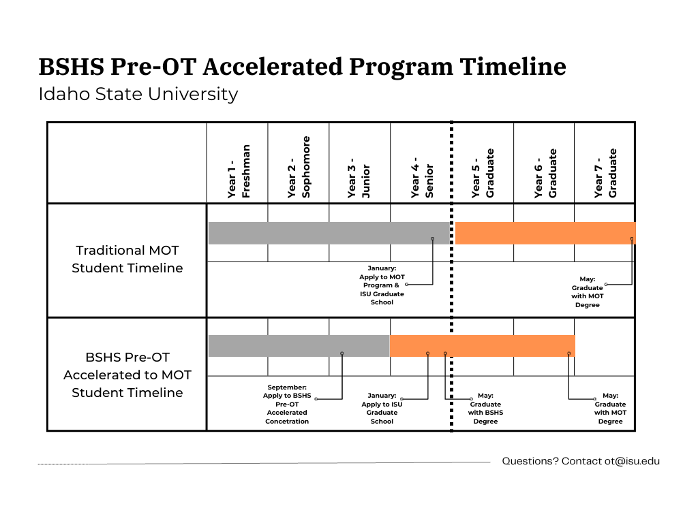

The BSHS Pre-OT Accelerated Concentration admits students on a competitive basis. Interested students are encouraged to meet with a member of the admissions committee to discuss their preparation for the program prior to applying. Appointments can be scheduled by emailing [ot@isu.edu](mailto:ot@isu.edu). Students are also encouraged to meet regularly with ISU’s Pre-Heath Advisor to ensure they are meeting general education, major core, and concentration requirements.

**Instructions**

Complete the following sections of the application and supplemental documentation:

* Form 1: Personal information
* Form 2: Educational history
* Form 3: Required coursework
* Form 4: Documentation of observation hours
* Form 5: Letters of Recommendation

Please submit the following supplemental documentation with your application:

* PDF of your Degree Works (showing progress toward your BSHS Pre-OT major)
* Unofficial copy of your transcripts from all colleges/universities attended
* Two letters of recommendation (in sealed envelopes as instructed in Form 5)
* Use your own words to create a two-page double spaced personal essay that answers this prompt:
  + Why did you select occupational therapy as a career? How does occupational therapy relate to you immediate and long-term professional goals? Describe how your personal, educational, and professional background will help you to achieve your goals.
  + Please provide your legal signature at the end of the essay to indicate authorship.

Submit the completed application and supplemental documentation to the Department of Occupational Therapy Admissions Committee by the close of business January 15, 2026. Applications may be submitted via email to [ot@isu.edu](mailto:ot@isu.edu). They may also be mailed or submitted in person to:

Mail: In Person:

Master of Occupational Therapy Program Garrison Hall, 3rd floor

921 S. 8th Avenue, Stop 8045 1400 E. Terry, Pocatello, Idaho

Pocatello, ID 83209-0009 Room 308

***Note:*** Students who are accepted into the concentration will be required to apply and be accepted into the ISU Graduate School during their senior year/first year of occupational therapy coursework. This application will require submission of official transcripts for all colleges/universities attended, as well as the application fee (currently $120).

**Form 1: Personal Information**

NAME: ___________________________________ DATE OF BIRTH: _________________________________

ADDRESS: _________________________________________________________________________________

CITY, STATE, and ZIP: _________________________________________________________________________

CONTACT TELEPHONE NUMBER (____) _______________ EMAIL: _______________________________________

NOTE: It is your responsibility to notify the MOT Program of changes in contact information during the application process.

I certify that the information contained in this application is true, complete, and correct. I understand that my admission to the Master of Occupational Therapy Program at Idaho State University is based on the validity of these statements. I agree to abide by and be subject to all rules, regulations, and policies of the Occupational Therapy Program at Idaho State University.

Applicant ______________________________________________________________ Date _____________________________

**Demographic Information (OPTIONAL):**

**Race and Ethnicity:**

Do you consider yourself to be of Hispanic/Latino origin: YES_____ NO______

Race- Please select one or more of the following groups in which you identify yourself to be a member:

_____ American Indian or Alaska Native

_____ Asian

_____ Black or African American

_____ Native Hawaiian or other Pacific Islander

_____ White

_____ Other____________________________

**Citizenship status:**

US Citizen_______ Other citizen________

If other, please list your country of citizenship: ____________________________________________

If other, do you have dual citizenship: YES_____ NO______

**Residency:**

Please list your current state of residence:___________________________________________

Please list your county of residence: ___________________________________________

How long have you been a resident of your state: ___________________________________________

How long have you lived in the US: ___________________________________________

If not a US resident, do you have a US Visa: YES_________ NO__________

**Gender:**

_____ Male

_____ Female

_____ Other_______________________________________________

**Form 2: Educational history and test scores**

**EDUCATION** List all colleges and universities attended after high school in chronological order:

**SCHOOL MAJOR DEGREE (yes/no/type) DATES**

1. ___________________________________________________________________________________________

2. ___________________________________________________________________________________________

3. ___________________________________________________________________________________________

4. ___________________________________________________________________________________________

5.____________________________________________________________________________________________

NOTE: Include a copy of unofficial transcripts from ALL colleges and universities you attended with your supplemental documentation.

**TEST SCORES (International Students ONLY)**

Please list your TOEFL Test scores below and attach an unofficial copy of the results to this application. Please note additional documentation may be required by the Graduate School or International Student office as part of the application process.

TOEFL Test date: ___________________________

_____ Total Computer Based Score

_____ Total Paper Based Score

_____ Section I computer based scored

_____ Section I computer based scored

**Form 3: Required coursework**

The BSHS Pre-OT Accelerated Concentration admits students on a competitive basis. Preference will be given to applicants who have grades of B or higher in required coursework. Applicants must complete the general education course requirements, major core requirements, and Pre-OT concentration requirements prior to enrolling in the Occupational Therapy coursework.

* **Please submit a PDF of your Degree Works showing progress toward your BSHS Pre-OT Concentration Degree.**

As the admissions team reviews coursework, they will be evaluating the following:

* Have you completed the following prerequisite courses with a grade of B or better?
  + Anatomy and Physiology (2 courses with labs)
  + Statistics
  + Human Development
  + Psychopathology
  + Sociology or Cultural Anthropology
  + Medical Terminology
* Have you completed all of the ISU general education requirements?
* Have you completed all of the BSHS major core requirements?
* Have you completed all of the BSHS Pre-OT concentration requirements?
* Will you have at least 92 credit hours completed prior to beginning to work on OT coursework?

If you are still working to fulfill these requirements at the time of application, please detail your plan to complete all of these requirements prior to beginning OT coursework in August 2026:

|  |  |
| --- | --- |
| **Course** | **Planned Semester** |
| Example: BIOL 3302/L | In progress Spring 2026 |
|  |  |
|  |  |
|  |  |
|  |  |
|  |  |
|  |  |
|  |  |
|  |  |
|  |  |
|  |  |
|  |  |
|  |  |
|  |  |

**Form 4: Documentation of observation hours**

**OBSERVATION EXPERIENCE:** As a requirement to apply to the program, students must show they have participated in an activity to learn about the profession of occupational therapy. Students may observe an occupational therapy practitioner for a minimum 10 hours or take an Intro to OT course (such as OT 2209). If you completed observation hours, please list the sites in which you observed the profession of occupational therapy under the direct supervision of a licensed occupational therapist OR occupational therapy assistant. If you took an Intro to OT class, please detail the course information below.

|  |  |  |  |  |  |
| --- | --- | --- | --- | --- | --- |
| **# OF HOURS** | **TYPE OF SETTING** (outpatient/rehab/psych/peds/  school/skilled nursing/hospice/  mental health /dev disability) | **OT/OTA SUPERVISOR** | **FACILITY** | **CITY/STATE** | **Dates FROM/TO** |

1. ___________________________________________________________________________________________

2. ___________________________________________________________________________________________

3. ___________________________________________________________________________________________

4. ___________________________________________________________________________________________

5. ___________________________________________________________________________________________

**Intro to OT Course**

|  |  |  |  |  |  |  |  |
| --- | --- | --- | --- | --- | --- | --- | --- |
| **Course Subject** | **Course Title and Department** | **Course #** | **Institution** | **Sem/Year** | **Letter**  **Grade** | **Credits** | **(Off.**  **use**  **only)** |
| **Intro to OT** |  |  |  |  |  |  |  |

**Form 5: Letters of Recommendation**

Please submit two total letters of recommendation. Letters should speak to your potential for success within the BSHS Pre-Occupational Therapy concentration as well as the Master of Occupational Therapy Program. Examples of people who could write a letter of recommendation include the occupational therapy practitioner who supervised your observation hours, a professor or academic advisor who can attest to your academic abilities, an employer, or a coach. Letters will not be accepted from relatives of the applicant.

Please provide the following information about the individuals writing your letters of recommendation.

**NAME/TITLE ADDRESS PHONE**

1. ___________________________________________________________________________________________

2. ___________________________________________________________________________________________

Please share the form on the following page with each of the individuals identified above. After they complete their recommendation, they must seal it in an envelope and provide their signature across the seal. You must return all envelopes to the department as part of your application packet. Envelopes that have been opened will not be accepted by the committee.

**Letter of Recommendation**

You have been asked to write a Letter of Recommendation for an applicant to the ISU Occupational Therapy Program. You may provide your recommendation directly on this form **OR** submit a written recommendation on letterhead with the top portion of this form.  **Please place your recommendation (form or letter) in a sealed envelope, provide your signature across the seal, and then return it to the applicant.** The applicant will submit your recommendation with the rest of the application. If you have any questions contact the ISU MOT program at (208) 282-4095.

**NAME/TITLE**: _________________________________________________________________________

**FACILITY/SCHOOL** __________________________________ **CITY/STATE**: _______________________

**EMAIL:** _____________________________ **APPLICANT:**_________________________________

**Did you directly supervise this applicant in an Occupational Therapy setting? ___YES ___NO**

**Name and location of clinical, school or other setting in which you have known applicant:**

**Length of time you have known applicant**:

Please provide a brief summary of your impression of the applicant's academic ability, personality characteristics (e.g. integrity, dependability, ability to get along with others), and potential for success in the profession of occupational therapy (if known). Provide specific examples if possible.

**SIGNATURE/TITLE: _____________________________________________ DATE:** ______________

Please place your recommendation (form or letter) in a sealed envelope, provide your signature across the seal, and then return it to the applicant.