Table of Contents
Welcome! 3
Land Acknowledgement 4
Helpful Links for New Faculty 5
IT New Faculty Resource Guide 5
HR New Employee Toolkit 5
HR New Employee Resources 5
Message from the President: 6
Strategic Plan and University Goals 6
Bold Path Forward 6
Office of the Provost 7
MyISU 8
How to use MyISU 8
MyISU Video 8
MyISU (login) 8
The Center for Learning and Instructional Excellence: 9
Accreditation 10
Colleges 12
Faculty Ombuds 13
Teaching Support 16
Credit & Grading Policies 16
ISU Course Policies 16
Closed Week & Final Exams 16
Syllabus Statements 16
AI Best Practices 16
AI Syllabus Statements 16
Tools for Checking Best Practices 16
Academic Violation Reporting Form 16
Assessment Resources 17
ITRC 18
Student Support Services 19
Dean of Students Office 19
ISU Navigate 20
Contact Navigate 20
Disability Services 20
The Counseling & Mental Health Center 21
Bengal Success Center 21
Academic Opportunities Program 22
Bengal Bridge 22
College Assistance Migrant Program 22
Intensive English Institute (IEI) 23
TRIO Programs 23
University Honors Program 24
University Tutoring Program 24
FERPA 25
Office of the Registrar 27
Class Overrides 27
Degree Works 29
The Office for Research 30
ASSERT (Aligning Stakeholders and Structures to Enable Research Transformation) 32
Annual Evaluations 33
Information for tenure track faculty only 33
Third Year Review 35
Tenure and Promotion 36
Faculty Senate 37
FPPC 38
RC 38
GERC 39
UCC 39
AIC 40
ASC 40
Policies 41
Purchasing 44
Jaggaer 44
PCARD 44
Human Resources 46
FMLA 47
Payroll 48
The Graduate School 49
Public Safety 51
About ISU 52
Mandatory Reporting 54

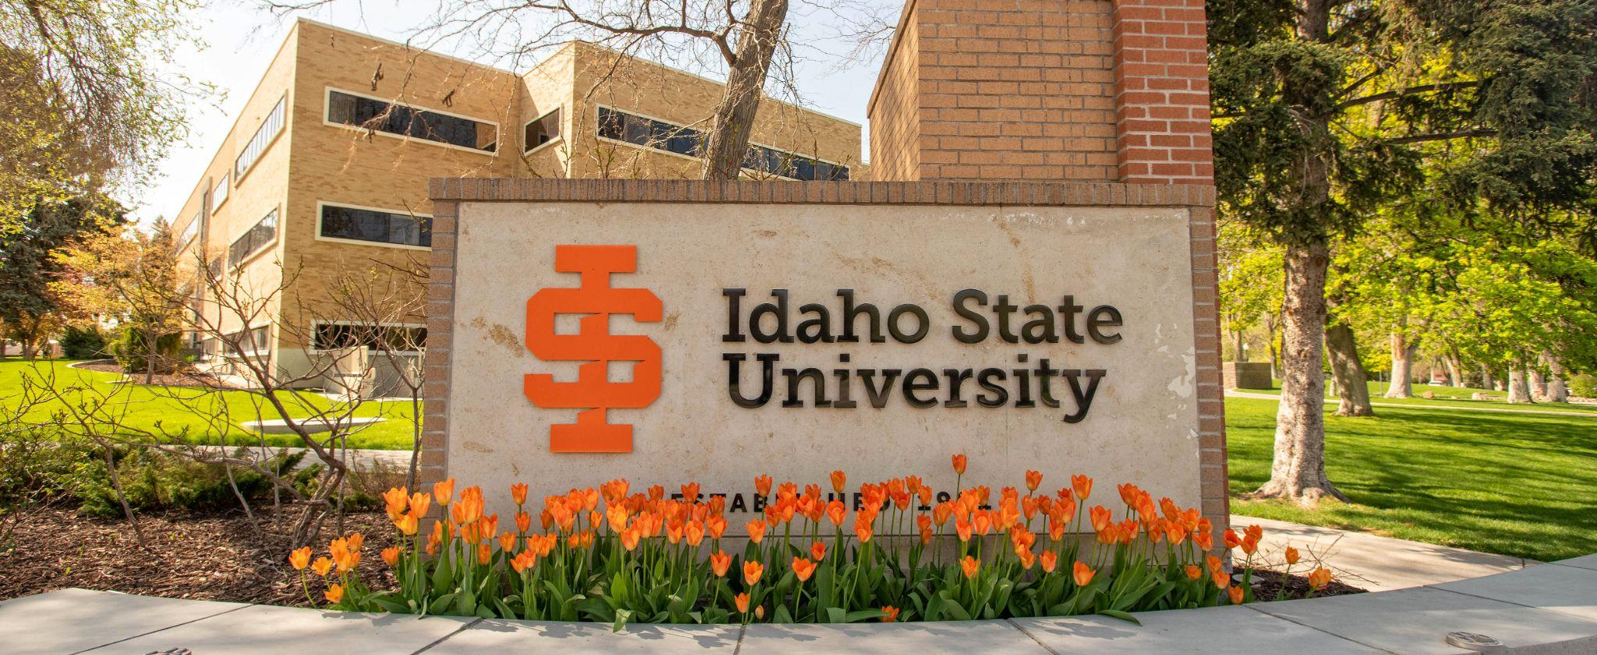

Welcome!
This guidebook, new in Fall 2025, was created to support you in your new role as a faculty member at Idaho State University.In this guidebook you will find resources, institutional practices and insights to help you navigate the culture and roles of a faculty member at our institution. We will be updating this guidebook often, so if you are looking for something and it is not included here, let us know. Please keep in mind that this guidebook is not intended to be read all at once - we hope that it will be useful for when you need specific information and that information is easy to find!
Our philosophy is that we hire the very best faculty and work to support our faculty in as many ways possible. Please, never hesitate to reach out to me and my office with any questions, at any time.

Laura Ahola-Young, Vice Provost for Faculty Affairs and Professor of Art
lauraaholayoung@isu.edu
(208) 282-5713
Rm 323 B, Administration Building
Pocatello Campus



Land Acknowledgement
Please see the above link for copies of the statement and for ways to incorporate the statement into your work.

Acknowledging Native lands is an important way to honor and respect Indigenous peoples and their traditional territories. The land on which Idaho State University’s Pocatello campus sits is within the original Fort Hall Reservation boundaries and is the traditional and ancestral home of the Shoshone and Bannock peoples. We acknowledge the Fort Hall Shoshone and Bannock peoples, their elders past and present, their future generations, and all Indigenous peoples, including those upon whose land the University is located. We offer gratitude for the land itself and the original caretakers of it.
As a public research university, it is our ongoing commitment and responsibility to teach accurate histories of the regional Indigenous people and of our institutional relationship with them. It is our commitment to the Shoshone-Bannock Tribes and to ISU’s citizens that we will collaborate on future educational discourse and activities in our communities

Helpful Links for New Faculty
IT New Faculty Resource Guide | 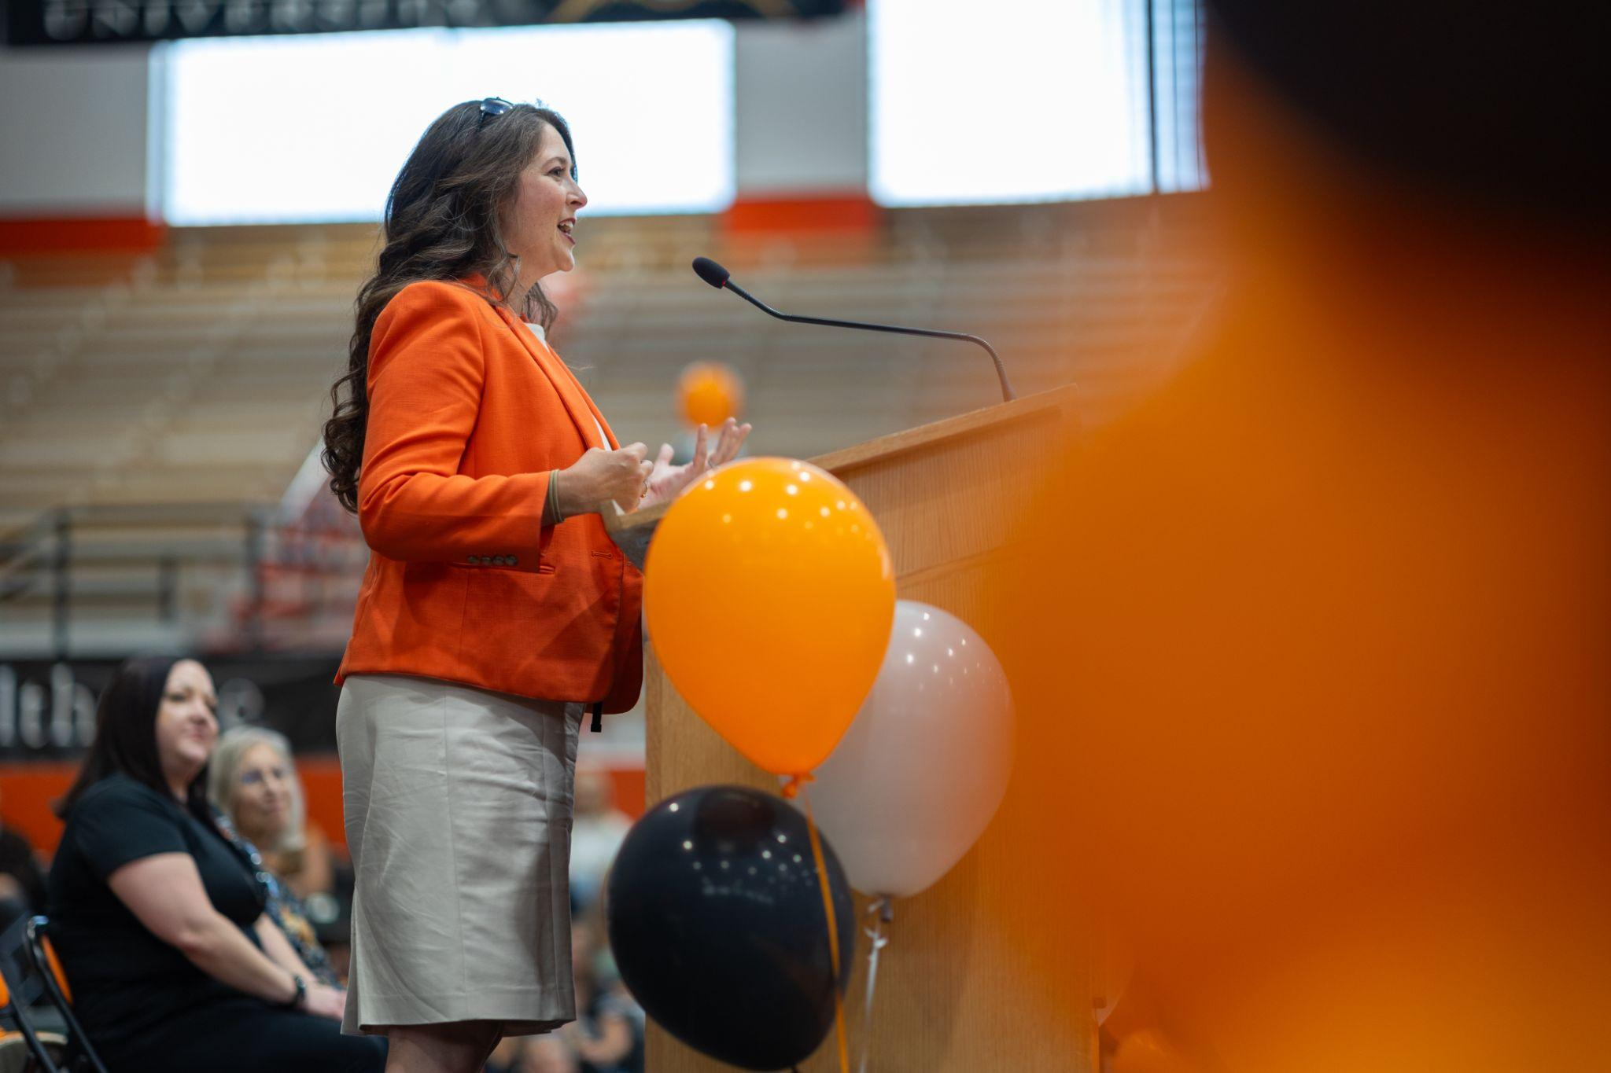HR New Employee Toolkit

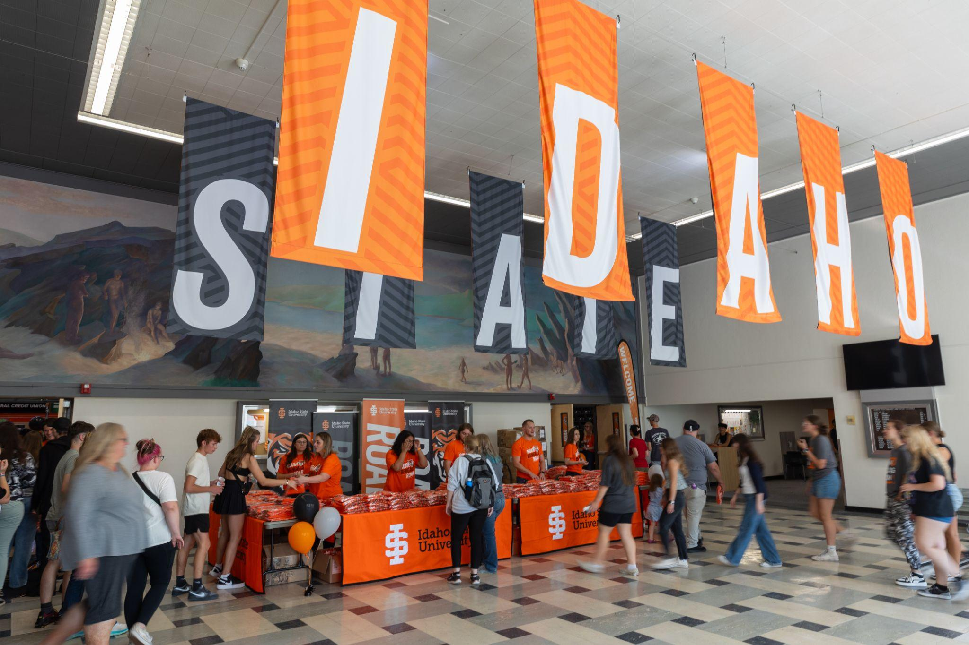HR New Employee Resources

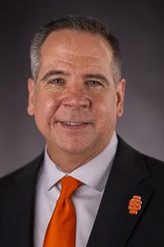 | Message from the President:  Welcome to Idaho State University! We are excited to have you join our Bengal community. As an institution, we are committed to bold action through teaching, research, creative works, and service. As a new faculty member, you play a vital role in advancing our mission by impacting our students, expanding knowledge, and strengthening the communities we serve. ISU values collaboration across disciplines, fostering an environment where ideas and perspectives come together to address challenges and create opportunities. Together, we work to increase access to high-quality education and resources, ensuring that all students have the support they need to succeed. We look forward to the contributions and positive differences you will make at Idaho State University.  Robert Wagner, PhD - President of Idaho State University

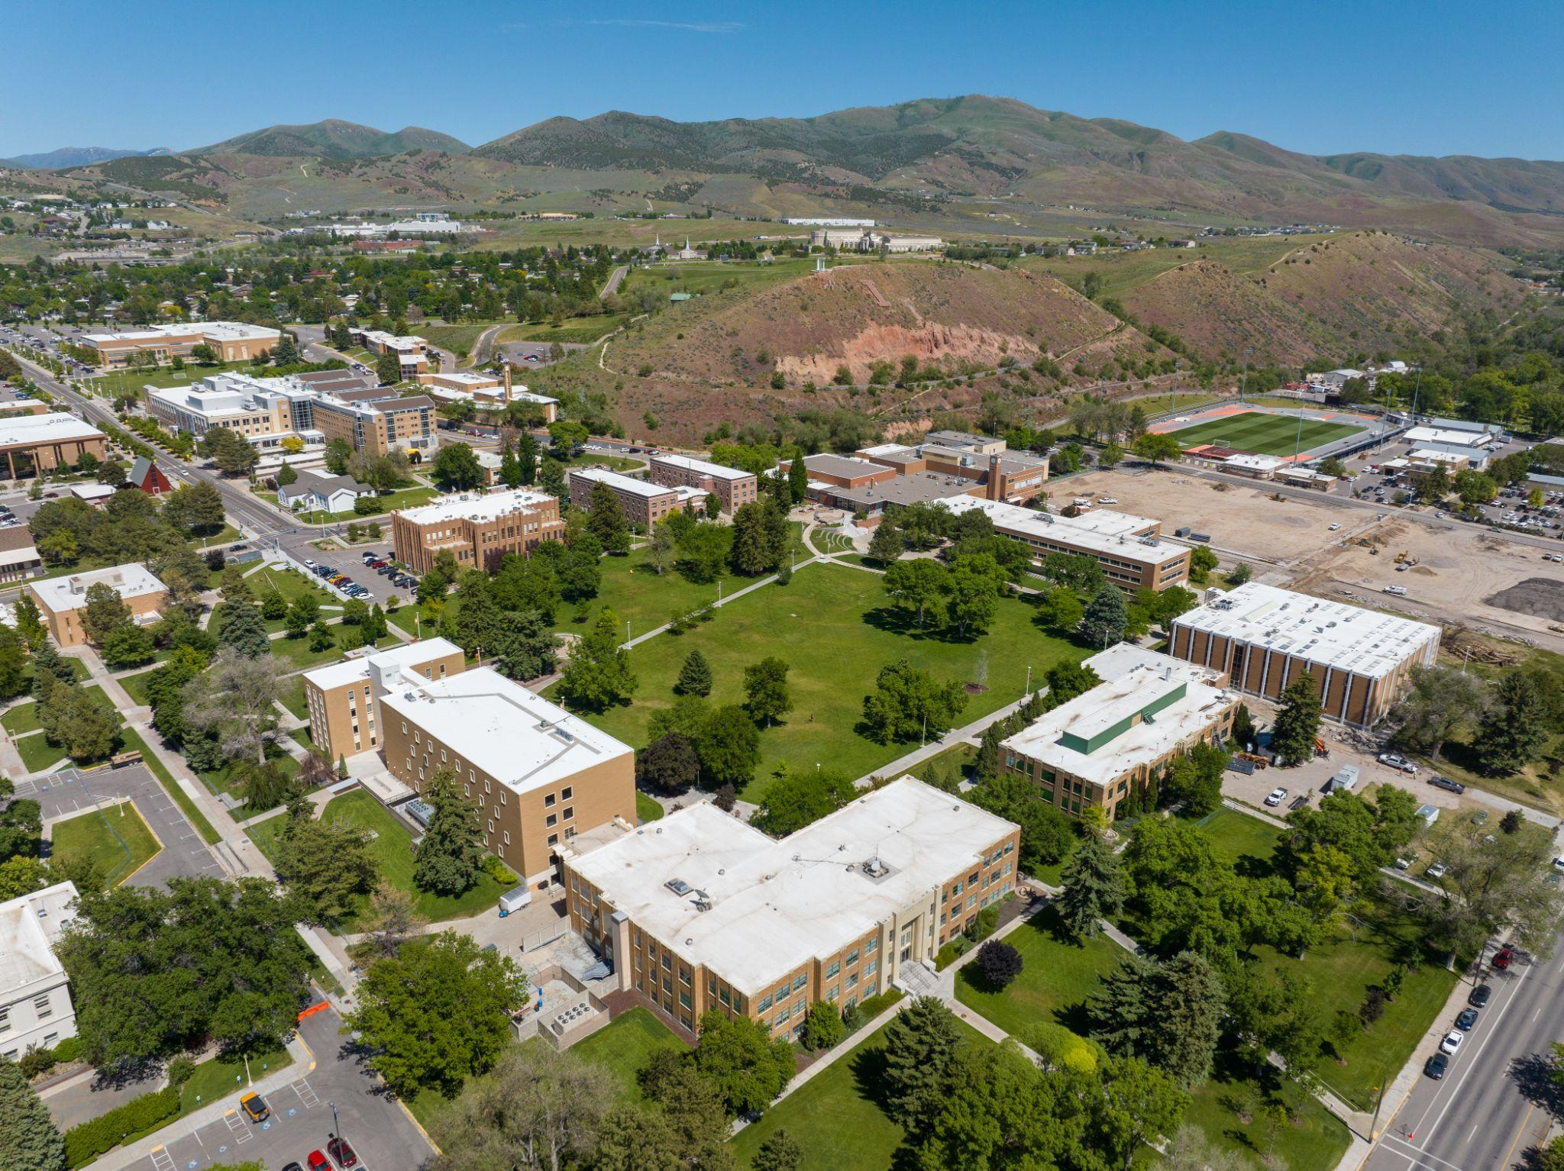  Strategic Plan and University Goals |  | 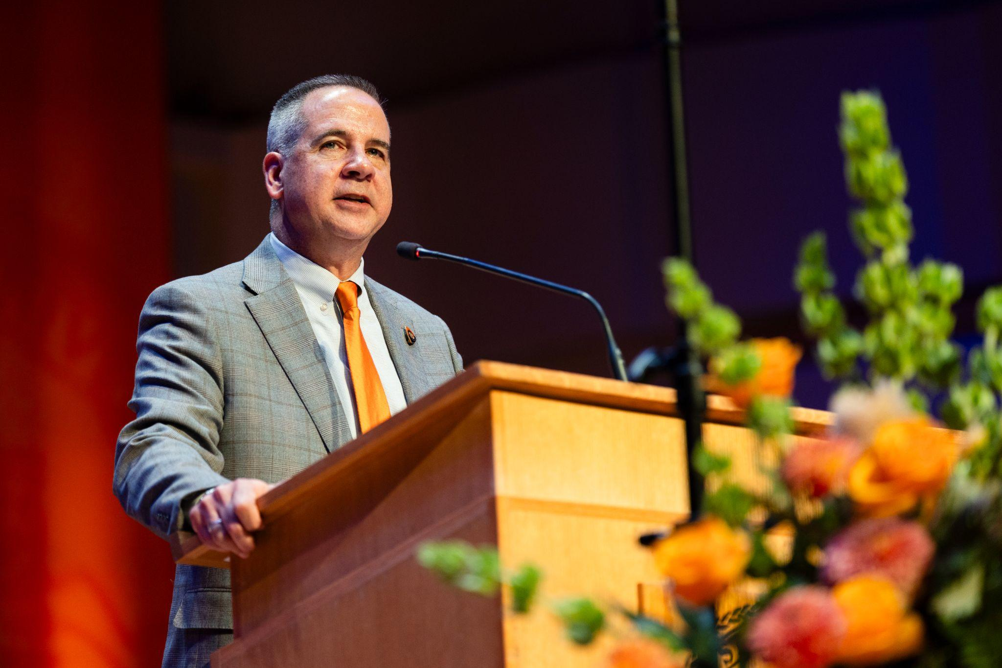  Bold Path Forward

Office of the Provost
The Provost’s Office is responsible for the overall excellence of all academic programs, faculty, and related operations. Key functions include leading academic strategic planning, overseeing faculty affairs from hiring to promotion, and guiding the development and assessment of curricula to ensure high-quality education.
Beyond program oversight, the Provost's office manages the academic budget, ensures compliance with accreditation standards, and supervises academic support units. They work closely with deans and department chairs to foster a robust academic environment, ultimately upholding and advancing the institution's educational mission.

Academic Calendar

  Adam Bradford - Provost |   Cindy Hill - Senior Vice Provost |   Laura Ahola-Young - Vice Provost

MyISU
MyISU is found on the main ISU website under Quicklinks and requires signing in. Resources and tools are available in MyISU including:

Class lists | Grade Entry | Degreeworks | Time Entry | Tax Information | Registration Overrides | Talent Management System (TMS - evaluation portal) | Travel Entry (Chrome River) | ISU ID | Access to ISU software: Box, Zoom, Jaggaer, Banner, Argos
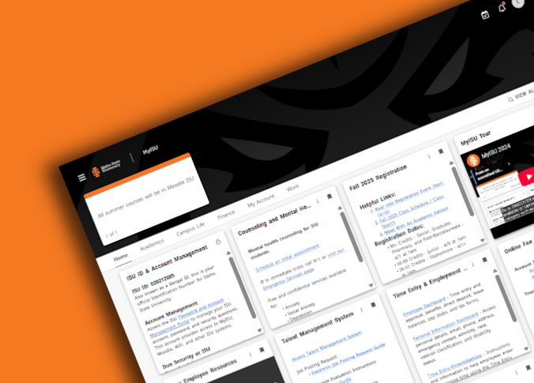  How to use MyISU |   MyISU Video

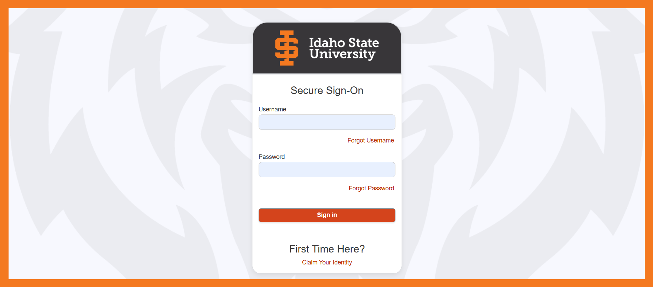

MyISU (login)

The Center for Learning and Instructional Excellence:
The Center for Learning and Instructional Excellence fosters a culture of student success and teaching excellence by promoting evidence-based and innovative instructional practices that are responsive to identified student needs, providing collaborative and structured support for faculty development, and aligning teaching methods with institutional goals. Through these efforts, the Center aims to enhance student success and create equitable opportunities for learning across our diverse academic community.

For questions or assistance, contact:
Doug McGee, PhD
douglasmcgee@isu.edu
208-282-2493

What to know: The Center for Learning and Instructional Excellence focuses on providing a wide scope of services to assist students and faculty, including:
- Workshops and Symposia
- Structured Teaching Certification Programs
- Peer Observation Programs
- Expanded Recognition for Faculty
- Enhancing Student Learning Outcomes

A schedule of events can be found on the Center for Learning and Instructional Excellence link above. You may also sign up to teach a workshop!

If you have ideas for services that you would like the Center to provide, please contact Doug McGee.

Accreditation
Who is Idaho State University’s accreditor?
The Northwest Commission on Colleges and Universities (NWCCU) is ISU’s institutional accreditor. The NWCCU is an independent, non-proﬁt membership organization recognized by the U.S. Department of Education as the regional authority on educational quality and institutional effectiveness of higher education institutions in the seven-state Northwest region of Alaska, Idaho, Montana, Nevada, Oregon, Utah, and Washington. It fulﬁlls its mission by establishing accreditation criteria and evaluation procedures by which institutions are reviewed.

University Leadership

What does accreditation mean for Idaho State University?
Accreditation by NWCCU provides important beneﬁts for ISU. Accreditation provides a means of demonstrating quality via an external review process, encourages continuous improvement through self-study and evaluation, and ensures institutional integrity. This evaluation process and approval affords substantial beneﬁts to ISU and its students.

Beneﬁts to students:

  - Without institutional accreditation, our students would not be able to apply for Federal Financial Aid.
University Resources
  - Students beneﬁt from the facilitation of transfer of credits between ISU and other accredited institutions.
  - Graduation from an accredited institution is required in order to apply for state licensure in some professions.
  - Accreditation communicates the quality and value of ISU degrees.

A large number of ISU students ﬁnance their education, at least in part, through Federal Financial Aid. In 2019-20, ISU undergraduates received $24 million in federal student loans, $14 million in Pell Grants, and $40 million in grant or scholarship aid from the federal government, state/local government, the institution, and other sources. Without accreditation, our students would not be eligible to receive Federal Financial Aid, and many would not be able to attend.
Policies and Guidelines

Beneﬁts to Idaho State:
  - Accreditation makes ISU eligible for federal grants and loans.
  - Accreditation allows ISU to maintain compliance with federal rules and policies.
  - Completion of the rigorous peer review process signals that ISU meets accreditation standards and is fulﬁlling its mission.

Specialized Accreditation for Colleges and Programs
Direct Reports
Many undergraduate and graduate programs maintain specialized professional accreditation. The Oﬃce of Institutional Research maintains the most up-to-date list of over 80 ISU programs with specialized accreditation.

Read more here: https://www.isu.edu/accreditation

Colleges
  CAL  Dean: Kate Reedy |   COSE  Dean: Jim Widmann |   COB  Dean: Sam Beldona |   COP  Dean: Tom Wadsworth
  COT  Dean: Jerry Anhorn |   COE  Dean: Esther Ntuli |   COH  Dean: Gabe Bargen |   KDHS  Dean: Rex Force

Library
Dean: Sandi Shropshire

Faculty Ombuds
A faculty ombuds serves as a confidential and neutral resource for faculty members seeking to resolve workplace issues or concerns. Operating outside of traditional administrative structures, the ombuds provides an informal avenue for exploring options, understanding university policies, and mediating disputes. Their primary role is to promote fair process, offer impartial advice, and help faculty navigate complex situations, ultimately contributing to a more constructive and equitable working environment within the institution.
The independence of the Ombuds Office is accomplished through:
- the University's recognition of it,
- a reporting structure in which the Ombuds reports to the University President through the Chief of Staff,
- freedom from direction or interference in the substance of its work,
- and by being distinct from all other organizational entities.
Impartial
The Ombuds will:
- be a resource for informal dispute resolution and problem- solving services only.
- not participate in internal or external formal investigative or adjudicative procedures.
- endeavor to provide visitors with information about relevant formal complaint processes to help educate them about their options.
Use of the Ombuds Office is voluntary and will not be a required step in any grievance process or University policy.
Informal
The Ombuds will:
- strive for impartiality, nonalignment and fairness in consideration of all visitors to the Office and the issues they raise.
- operate with the aim of supporting all visitors and parties in the most effective way possible and will facilitate communication and problem-solving in a way that does not take sides or favor a particular outcome.
- avoid involvement in any matter in which their private interests, real or perceived, may conflict with their ability to be truly impartial and independent in their role.

Confidentiality
Confidentiality is the defining characteristic of the Ombuds Office.
- The identity of those seeking assistance from the Ombuds and all communications with them are confidential as permitted by law.
- The Ombuds will hold all communications in strict confidence and will not reveal--and must not be required to reveal--the identity of visitors to the Ombuds Office.
- Any memory notes taken while working with visitors will be shredded when the matter is resolved or becomes dormant.
Exceptions to Confidentiality
The Ombuds will not reveal any information disclosed to them in confidence except in accordance with the IOA Standards of Practice, including disclosing otherwise confidential information if they determine what might be an imminent risk of serious harm.
International Ombuds Association

Teaching Support
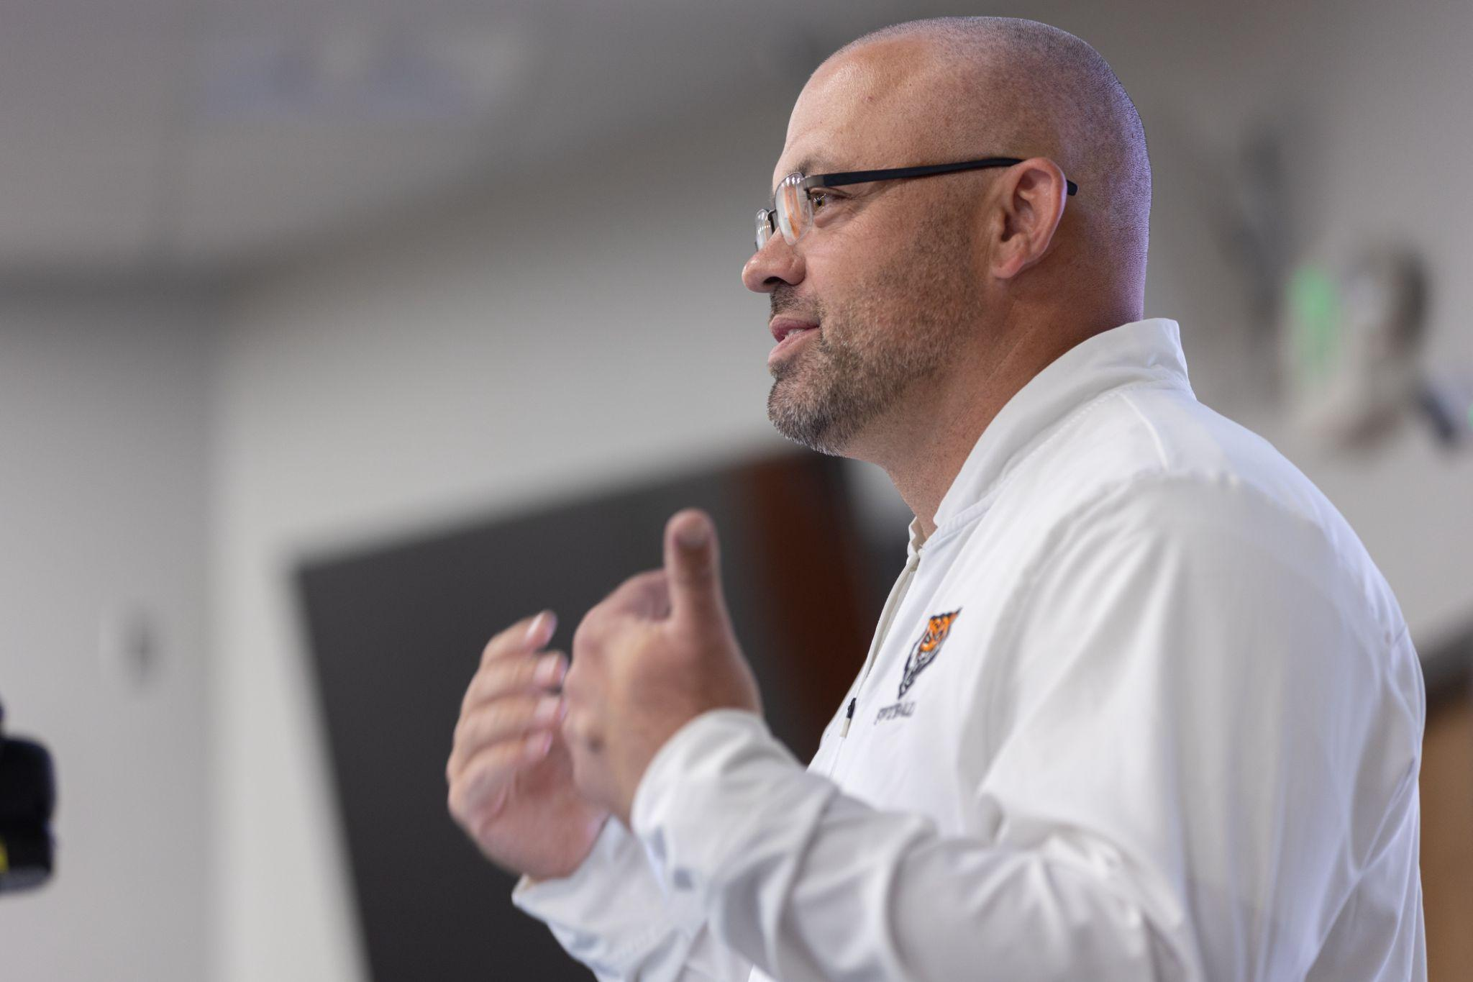  Credit & Grading Policies | 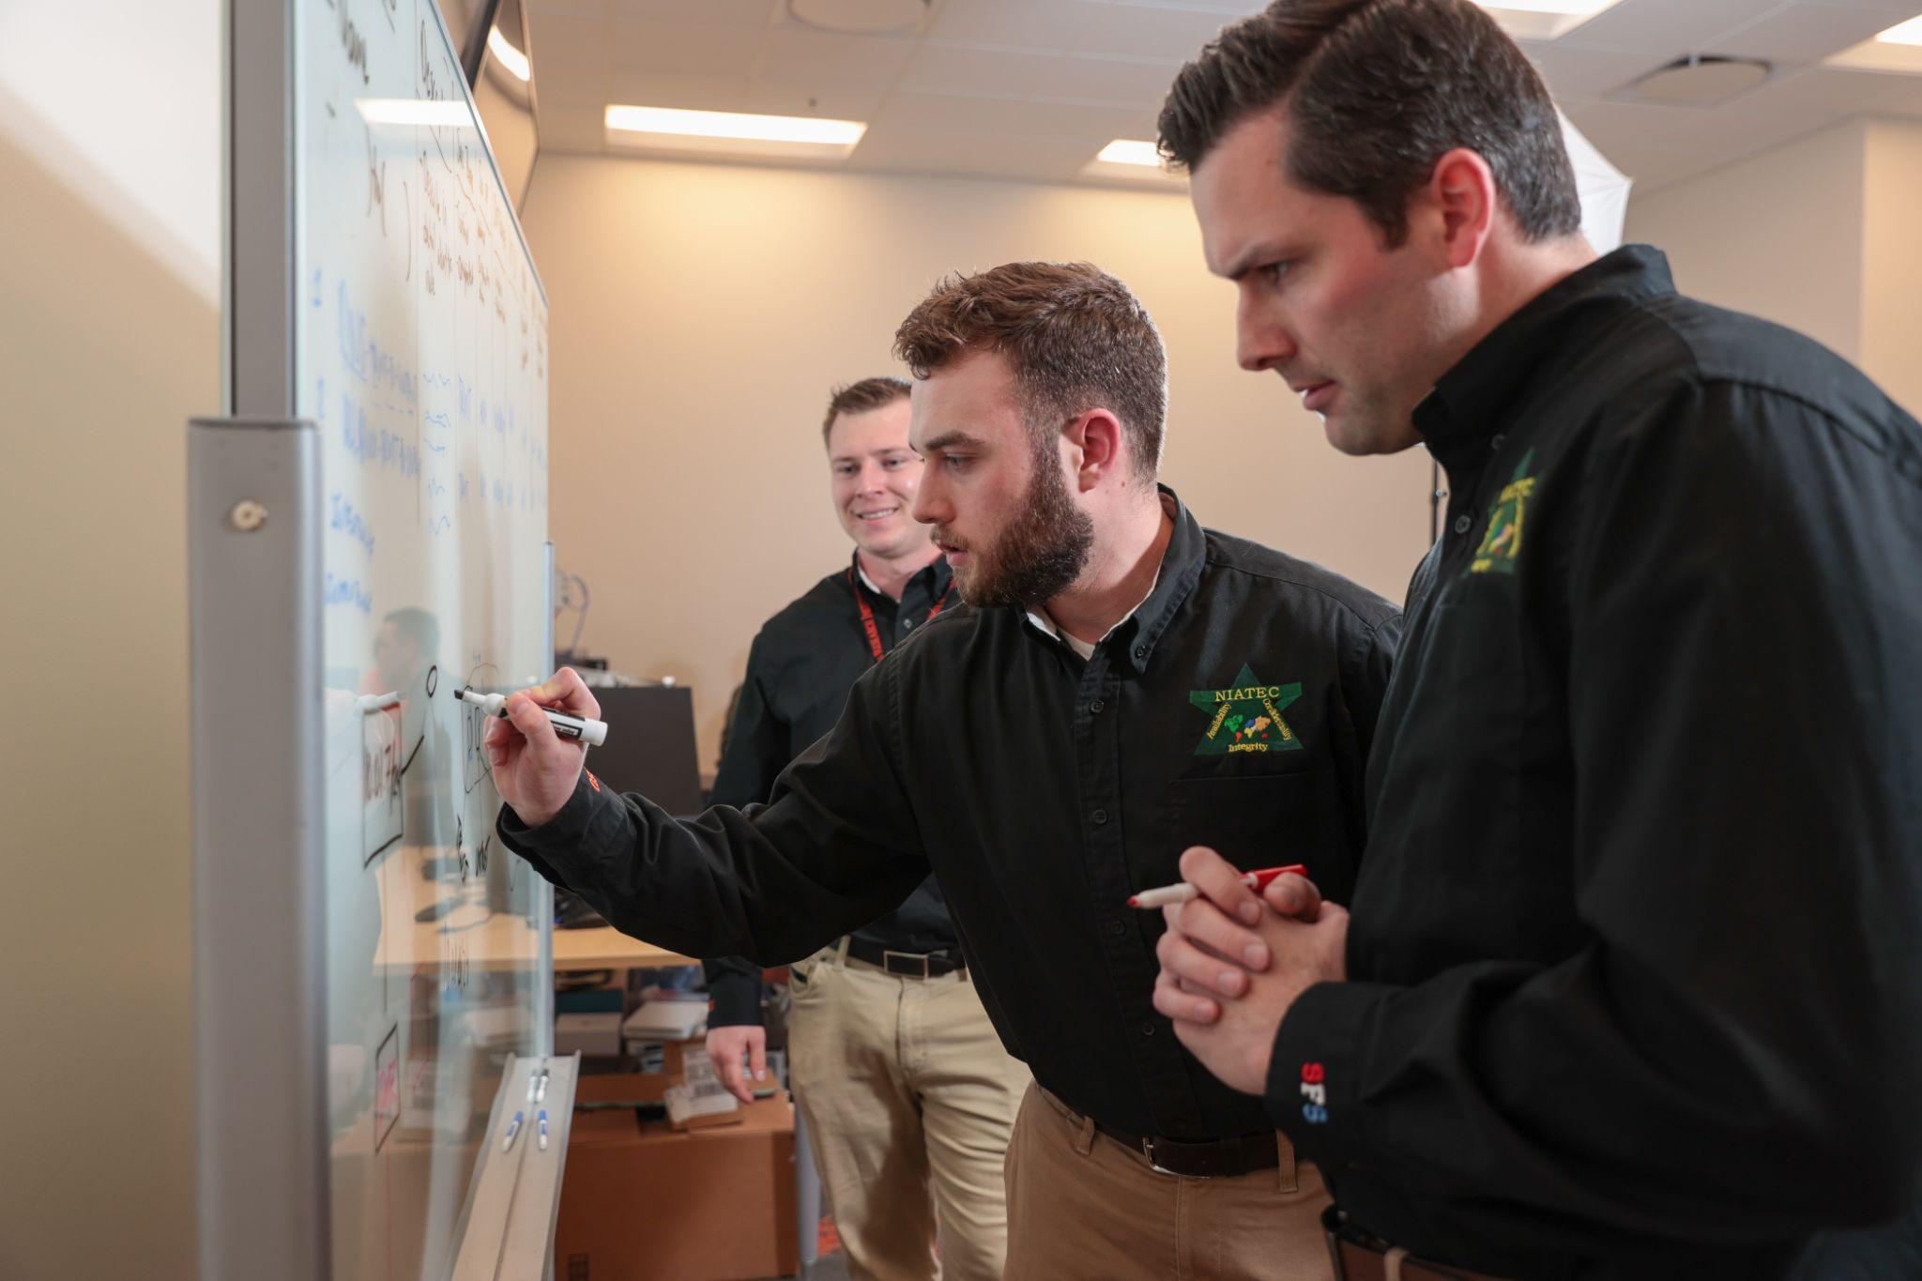  ISU Course Policies | 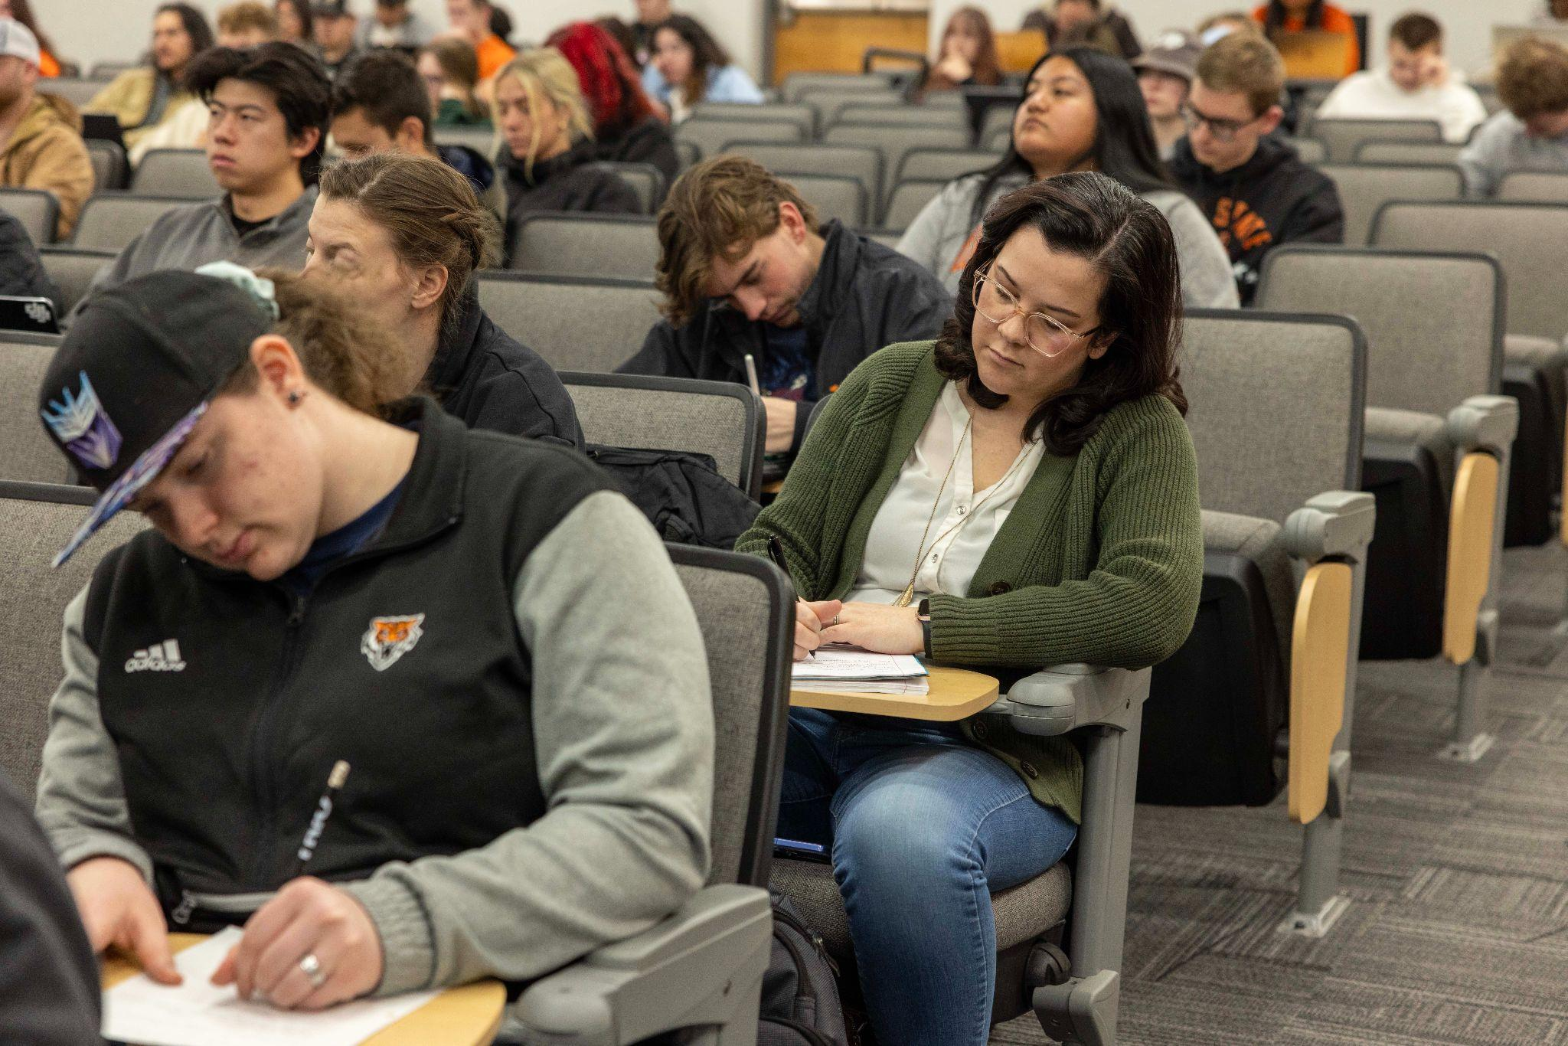  Closed Week & Final Exams
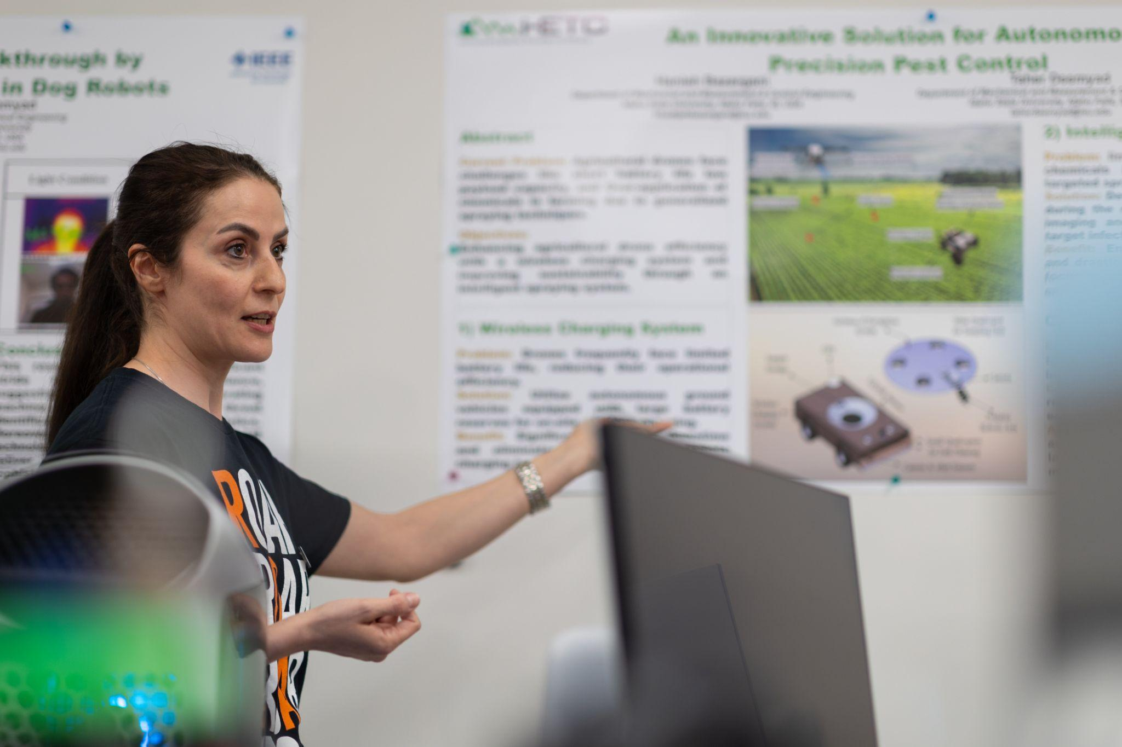  Syllabus Statements |   AI Best Practices |   AI Syllabus Statements
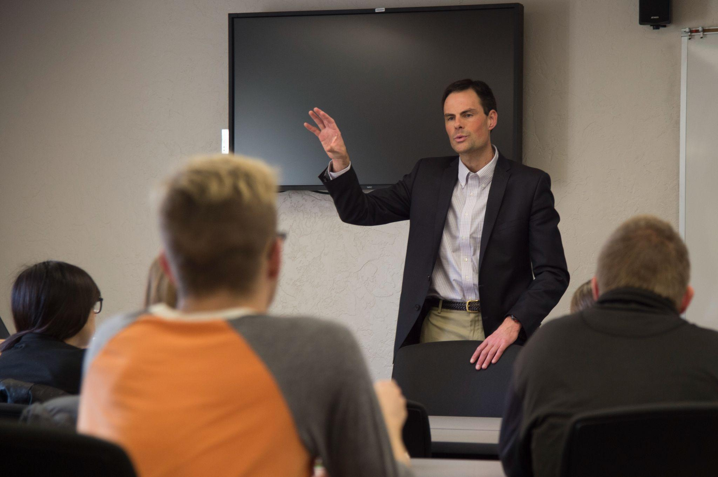  Tools for Checking Best Practices | 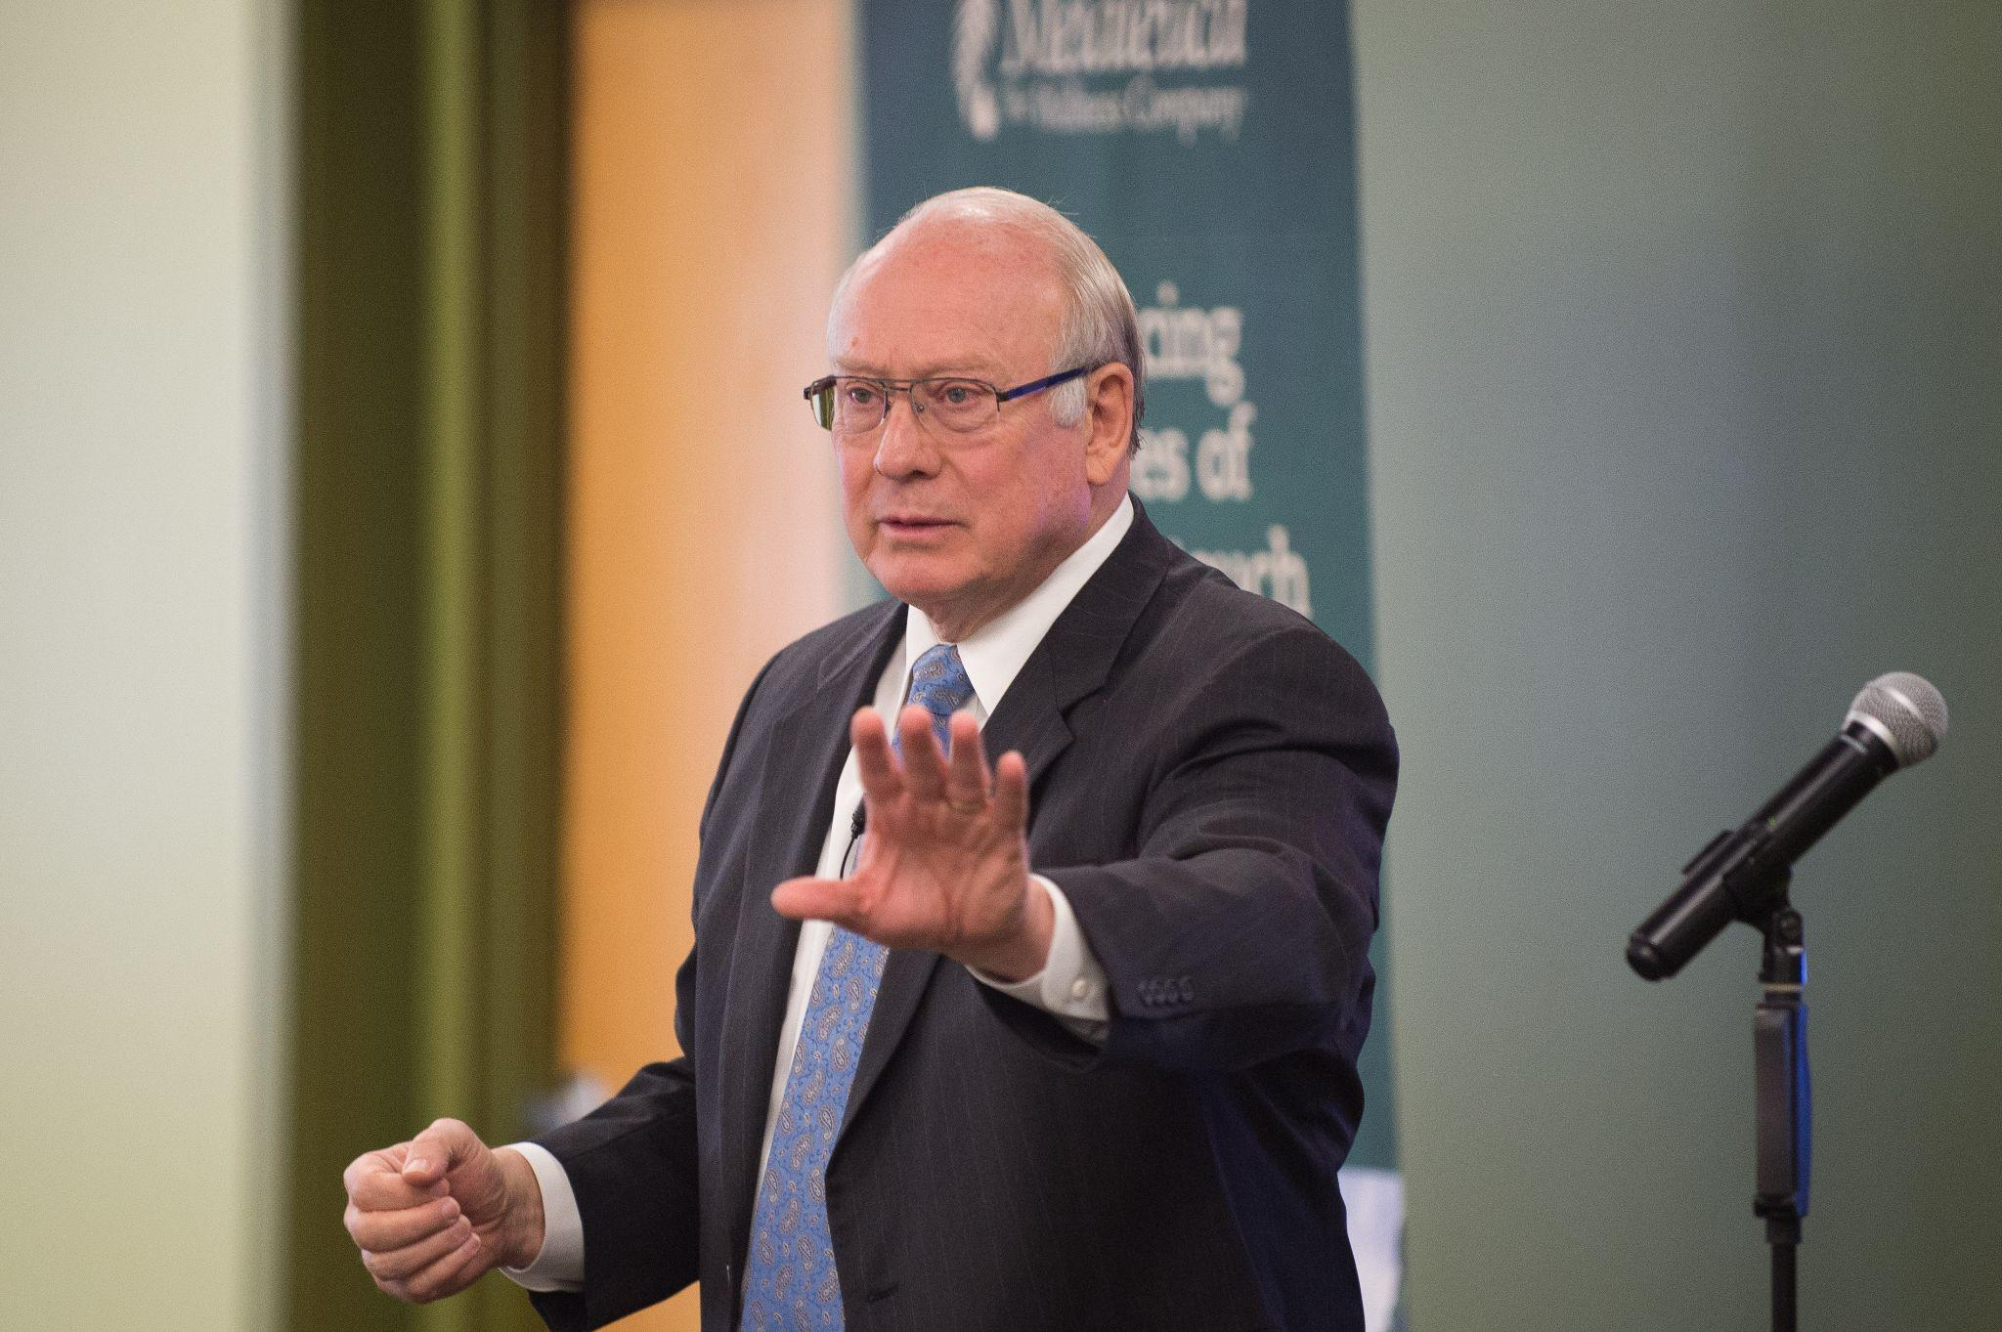Faculty Tutorial: Steps for Determining Academic Integrity Violation |   Academic Violation Reporting Form

Assessment Resources
Assessment is a cornerstone of effective teaching. At Idaho State University, we use assessment not just to measure what students learn, but to improve learning outcomes and strengthen our programs over time. It’s also essential to meeting expectations set by the Idaho State Board of Education and our accreditor, the Northwest Commission on Colleges and Universities (NWCCU). In addition, many academic programs are subject to specialized accreditation from external agencies within their fields, which often carry their own assessment standards and reporting requirements.
At ISU, there are two primary assessment processes. One is led by the General Education Requirements Committee (GERC), which oversees assessment of general education courses. The other is governed by the University Assessment Review Committee (UARC), which focuses on the assessment of academic programs. In some cases, assessment practices may also be governed by discipline-specific accreditors. However, even in those cases, programs are expected to share assessment findings with the university—either through annual reporting or as part of the seven-year program review process. All of these efforts support continuous improvement and ensure alignment with institutional and statewide goals.
Every course and academic program has established learning outcomes that describe what students should know or be able to do. Course syllabi should always include the relevant course learning outcomes (CLOs), and if you’re new to teaching a course, be sure to consult your department chair to confirm the CLOs and ensure your course design aligns with them.
Good assessment starts with intentional design. As you plan your course, consider what you want students to achieve and how you’ll measure it. That includes choosing the right types of assessment tools (exams, projects, presentations, etc.), designing them to effectively measure learning, gathering and analyzing the results, and using what you learn to improve your course or contribute to broader program discussions.
The Center for Learning and Instructional Excellence is here to help. We offer individual consultations, a growing collection of resources, and workshops throughout the year to support strong, practical assessment practices that serve both faculty and students

ITRC
The Instructional Resource Center is here to help Idaho State University faculty leverage technology to achieve effective learning-centered instruction. By collaborating with other University support services, the ITRC offers faculty one location to find the best approaches to teaching and learning. As a team, they provide faculty with a complete technology resource for all levels of instruction. Because they are aware of the challenges instructors face in terms of time and comfort with technology, their staff can aid you with the instructional design process for preparing and delivering technology-enhanced course materials.

If you have questions, concerns, or need assistance, contact:
The ITRC Staff
College of Education Building, 356
208-282-5880
itrc@isu.edu
Make an appointment

What to know: The ITRC aims to enhance the educational experience by ensuring faculty and students have the resources and knowledge needed to use instructional technologies effectively. The ITRC provides services such as:
- Instructional Design Support: Assistance in developing online and hybrid courses using modern teaching methods.
- Technology Training: Workshops, one-on-one consultations, and training on educational technologies.
- Multimedia Development: Help with creating videos, graphics, and other multimedia for educational purposes.
- Moodle/Canvas Support: Assistance with ISU's learning management system, Moodle/Canvas, including troubleshooting and course setup.
- Innovative Tools: Access to tools and technologies like lecture capture systems, virtual reality, and software for content creation

Student Support Services
  Dean of Students Office |   Assistant VP for Student Affairs and Dean of Students: Matt Daily
Matt serves an appellate role for student conduct cases, leads the campus CARE Team, supervises the Dean of Students Office, Veteran Student Services and Leadership and Engagement. They also serve as the ISU Advisor for ASISU.

  ISU Navigate | ISU Navigate links administrators, advisors, faculty, and students through a single platform, providing predictive analytics to facilitate communication and ensure early intervention in support of student persistence and success. This powerful interactive tool will help us identify support gaps and reach out proactively on behalf of students before they reach a critical impasse in their academic journey.  Contact Navigate

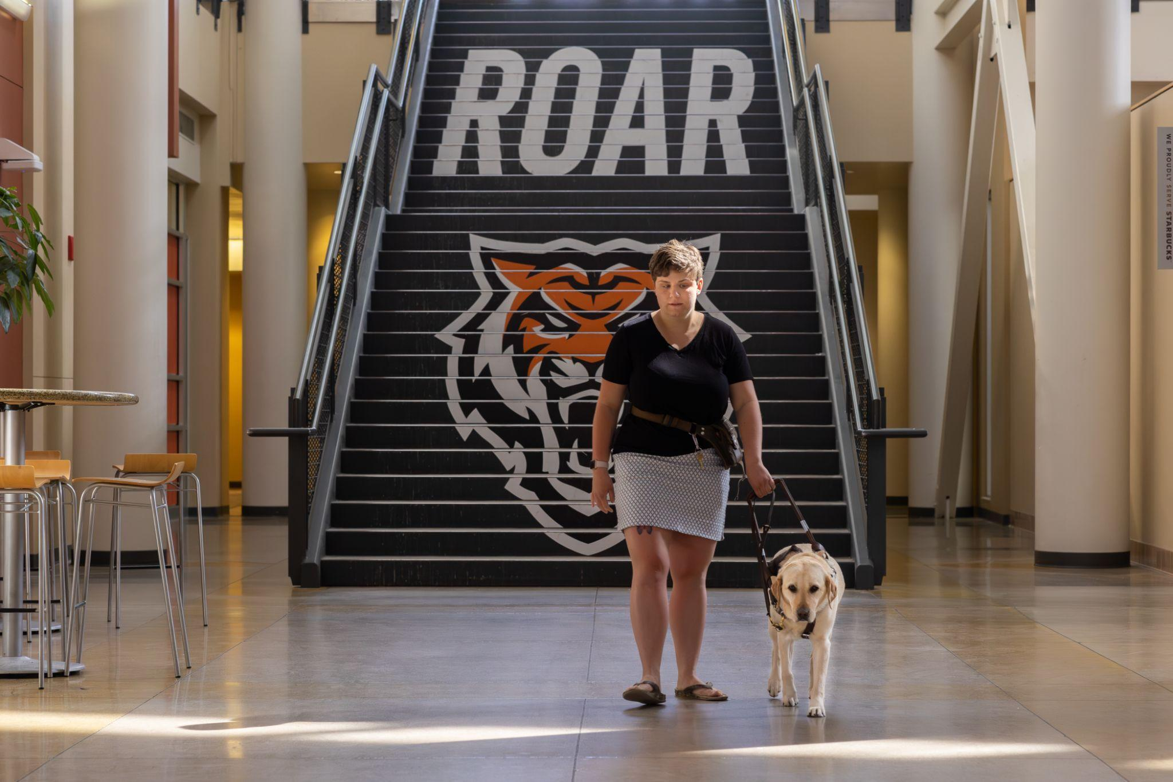  Disability Services |   Director/EIT Coordinator: Karina Rorris
The Disability Services office provides support to students with disabilities to ensure equal access to education. These services typically include accommodations such as extended test time, note-taking assistance, accessible materials, and physical campus accommodations. The goal is to create an inclusive learning environment where students with disabilities can succeed academically.

  Director: Rick Pongratz, Ph.D., LPC, Licensed Psychologist | 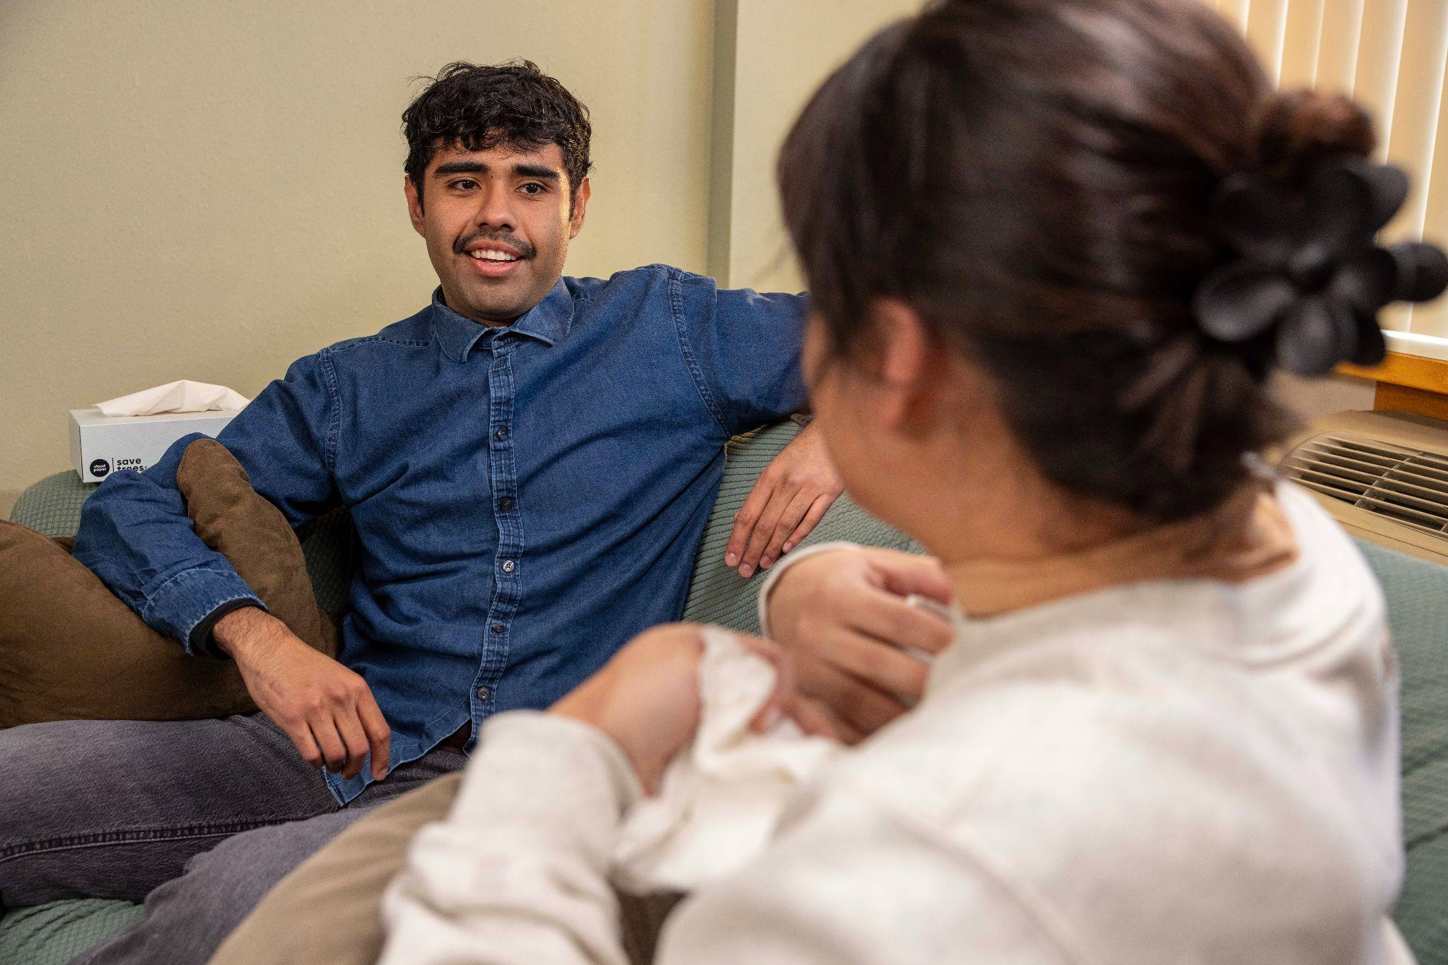  The Counseling & Mental Health Center |   Asst Clinical Director: Kristin Stewart Yates, Ph.D., LCPC
The university Counseling and Mental Health Center (CMHC) serves Idaho State University and its community with a dual mission. Our counseling services mission is to support the academic, emotional, social, vocational, spiritual, cultural, and professional development of students and other members of the ISU community by offering counseling, outreach, consultation, training, and educational and health promotion services.



Bengal Success Center
The Bengal Success Center is focused on personalized academic support for all students and houses a number of specialized programs, such as University Tutoring, Bengal Bridge, University Honors, the Intensive English Institute, TRIO, High School Equivalency Program (HEP), and College Assistance Migrant Program (CAMP). Additionally, the Center also houses the Center for Learning and Instructional Excellence, which provides enhanced opportunities and training for faculty professional development, with a focus on promoting excellence in both student learning and faculty teaching.
  Academic Opportunities Program | The Academic Opportunities Program maximizes student success by providing coursework that supports the development of academic strategies, facilitates successful transitions to progressively more complex university environments and expectations, and promotes the development of leadership skills and community connections.
The Bengal Bridge Program serves as Idaho's largest summer bridge initiative, designed specifically for recent high school graduates transitioning to college life. The program creates an academically rigorous environment focused on general education coursework while providing comprehensive support services. |   Bengal Bridge
Key components of Bengal Bridge include:
Structured general education courses | Intensive supplemental instruction | 1:1 faculty mentoring relationships | Dedicated academic tutoring services | Specialized academic mentoring and guidance | Peer mentorship opportunities
  College Assistance Migrant Program | CAMP represents a federally funded initiative designed to support students from migrant and seasonal farmworker backgrounds during their critical first year of university studies. The program provides comprehensive support services to ensure academic success and retention.
Key components of CAMP include:
Specialized academic tutoring | Professional development workshops | Scholarship assistance | Dedicated academic advising | First-year completion support
IEI delivers comprehensive English language instruction for international students seeking academic preparation for university studies. The program emphasizes academic English proficiency through expert instruction and cultural integration support. |   Intensive English Institute (IEI)
Key features of IEI include:
Advanced English language instruction | TESOL-certified faculty | Academic preparation courses | Cultural integration support | University transition assistance
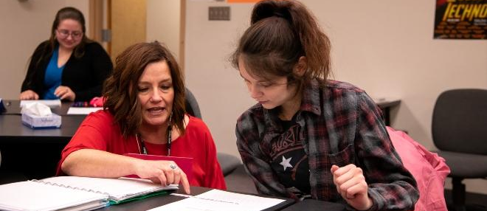

TRIO Programs
The TRIO McNair Scholars program focuses on preparing eligible students for doctoral studies through intensive research experiences and comprehensive academic support. The program serves first-generation, limited income, and underrepresented students in their final two years of undergraduate study. | TRIO McNair Scholars services include:  Research opportunities Faculty mentoring | Graduate school preparation | Professional development | Academic support services | Conference presentation opportunities
TRIO SSS services include:  Proactive academic advising | Specialized tutoring services | Financial literacy guidance | Career development support | Academic skills workshops | Social support networks | TRIO SSS provides comprehensive support for first-generation students, limited-income students, and students with disabilities. The program emphasizes holistic student development and academic success through various support services.
  University Honors Program | As Idaho's exclusive Honors Bachelor's degree-granting program, the University Honors Program provides enriched educational experiences for high-achieving undergraduate students. The program emphasizes academic excellence, intellectual growth, and professional development.
Key features of University Honors include:
Advanced coursework | Enhanced learning opportunities | Specialized mentoring | Research opportunities | Professional development activities | Enriched social and academic experiences
University Tutoring provides comprehensive academic support services at no cost to current ISU students. The program emphasizes personalized learning assistance through various specialized centers and services. | 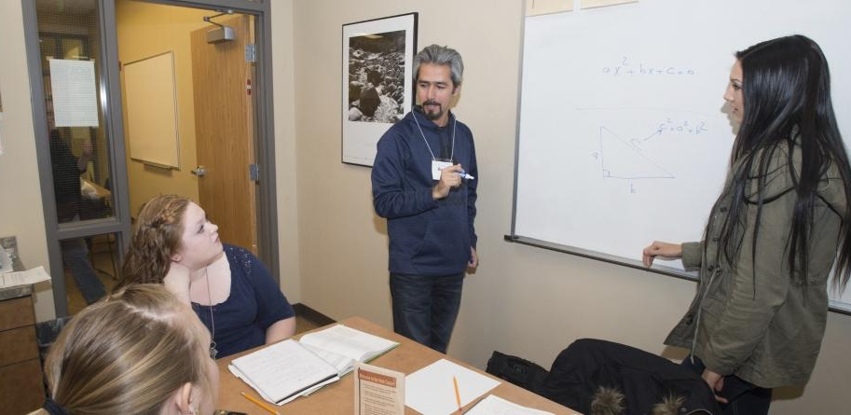  University Tutoring Program
Key services of University Tutoring include:
Math Center | Writing Center | Individual and small group content-specific tutoring | Small group study sessions | Cross-campus academic resource coordination

FERPA
The Family Educational Rights and Privacy Act is a federal law enacted in 1974 designed to protect the privacy of student education records. FERPA grants certain rights to students and their families regarding the access, amendment, and control over the disclosure of educational information. It applies to all educational institutions that receive funds from the U.S. Department of Education.

If you have any questions about FERPA, contact
Aubrie Nield
aubrienield@isu.edu
208-282-3234

What to know: FERPA provides the following provisions:
- Access to Records - Students have the right to inspect and review their educational records
- Amendment Requests - Students can request corrections to records they believe are inaccurate or misleading
- Consent to Disclose - Schools must obtain written consent from students before disclosing personally identifiable information from their records, except in specific circumstances outlined by FERPA
- Directory Information - Schools may disclose certain information categorized as “directory information” (such as name, address, phone number, and major) without consent, unless the student opts out
- Annual Notification - Schools must inform students annually of their FERPA rights

It’s Important to Remember…
- Do not use the University ID number of a student in a public posting of grades or any other information.
- Do not link the name of a student with that student’s University ID number in any public manner. Do not leave graded materials for students to pick up in a stack that requires sorting through the papers of other students.
- Do not hand graded information back to the group once it has been graded if it is a group grading situation.
- Do not share the progress of a student with anyone other than the student without the student’s written consent.
- Do not provide anyone with lists or files of students enrolled in your classes for any commercial purpose.
- Do not provide course schedules or assist anyone - other than university employees - in finding a student on campus.
- Do not access the records of any student for personal reasons.
- Do not store confidential information on any computer, unless that information is required and secure from intrusion.
- Do not include a student's grades, GPA, classes, etc. in a letter of recommendation without written consent of the student.

Office of the Registrar
Registration at Idaho State University (ISU) is the process through which students enroll in courses for an upcoming semester. It typically involves selecting classes, meeting with an academic advisor if needed, and using ISU’s online system (MyISU) to add courses to their schedule. Students must ensure they meet any prerequisites for their chosen courses and register within designated time frames to secure their spots. Additionally, they may need to address financial, residency, or other administrative requirements before completing the process.

If you have any questions, please contact the Registrar’s Office 208-282-2661 reginfo@isu.edu

Class Overrides
- Includes prerequisites, corequisites, total override (includes both prerequisite and corequisite) and instructor approvals (this is set up at the section level).
- Faculty are responsible for providing course overrides for the classes they offer if they choose to enroll a student who does not meet the course entry requirements.
- Only the primary instructor can provide overrides to students in MyISU.
- The department chair can do overrides in Banner using SFASRPO. A report of all overrides granted is available to all deans and department chairs in Argos.
Requisite Requirements:
- Prerequisite and corequisite requirements do not refer to any academic standing, but instead refer to when after the term is over and graded, a student no longer meets what is necessary to be enrolled in a particular course.
- During registration for a future term, if a student is currently registered for the pre-co/requisite course, they may register for the "next" course. After the term ends, if they get an insufficient grade, they are dropped from the course in the coming term.
  - For instance, if a student is registered for MATH 1143 in fall term, they are allowed to register for MATH 1160 for spring. If they get a D+ or lower in MATH 1143, they are not sufficiently prepared to move on to MATH 1160 and they are immediately dropped after the term rolls.
Emailing Registration Questions:
- If you are sending emails to reginfo@isu.edu please include a student ID number, the CRN number for the class(es) in question, and the error message the student is receiving.
- Also send an email to reginfo@isu.edu if you encounter ongoing issues with specific courses or populations of students being unable to register. This enables them to address the issue and streamline the registration process for students.
Change of Program/Major:
- For undergraduate students, change of programs (i.e., degree, major, minor, concentration or catalog year) must go through the Change of Major Request process through academic advising.
- Change of programs for graduate students is managed by the Graduate School.
Credit Overrides:
- Requests for credit increases (above 18 for undergraduate students) go through the Dean’s Office of the student’s major for approval.
- Requests for credit increases (above 16 for graduate students) go through the Graduate School for approval.

Degree Works
Degree Works is an electronic degree audit system that tracks courses from a students’ transcript and organizes them so an advisor and the student can quickly and easily identify complete and outstanding degree requirements by category.
It tracks all Degree Requirements listed in the ISU catalog, for example:
- General University Requirements
- General Education Objective Requirements
- Major, Minor or Concentration Requirements
- Program Electives
- General Electives
- Remedial Coursework
- In-Progress Coursework
- Courses not counted toward the degree or certificate
Each College has their own Advising Coordinator- reach out to your College for contact information.

For assistance with Degree Works, contact: dgwinfo@isu.edu Ann Davidson 282-2823 Sarah Mead 282-5273
What to know:
- Faculty and staff members currently assigned an advising role in Banner also have access to view those they advise in Degree Works.
- Degree Works is accessible through MyISU, the Degree Works Quick Guide is helpful.
- The programs of study listed in Degree Works are based on the catalog. Please be aware that any program changes must be routed through Undergraduate Curriculum Council (UCC) or Graduate Council (GC) to be included in Degree Work

The Office for Research
The Office of Research Development supports the growth of university-based research and creative scholarship. According to the National Organization for Research Development Professionals,

“Research Development encompasses a set of strategic, catalytic, and capacity-building activities that advance research, especially in higher education. Research Development professionals help researchers become more successful communicators, grant writers, and advocates for their research. They help researchers bring new ideas to life.

Research Development professionals also serve their institutions. They create services and resources that transcend disciplinary and administrative barriers and create programs to spur discovery.”

At ISU, the goal of research development is to advance the culture of research and creative scholarship across the ISU community. Research includes discovery and innovation in the sciences and engineering, scholarship in the humanities, as well as creative works and performances in the arts. To achieve this goal, the ISU Office of Research Development will primarily offer two types of support to faculty and staff involved in research: Direct support for preparing proposals and strategic activities to enhance grantsmanship.

Examples of Direct Proposal Support: Working with faculty to identify funding opportunities, helping with identifying collaborators and building teams, individual faculty training, supporting navigating the grant lifecycle, reviewing solicitations, tailoring projects to specific funding opportunities, and increasing the capacity of faculty to identify and win grants.

Examples of Strategic Activities: Developing and hosting workshops, identifying and creating resources for researchers, working to align research projects with strategic institutional priorities, working with partners to increase grant opportunities, and expanding relationships with funders.

The Office of Research Development works collaboratively with the Office of Sponsored Programs and Support. Research Development provides optional services that enhance the number of awards submitted and the competitiveness of those awards. The Office of Sponsored Programs is a mandatory service; all grant seekers must work with that department.

To work with the Office of Research Development, please reach out to the Director of Research Development, Dr. Amy Wuest (amywuest@isu.edu). If you would like to receive direct support on a project, please contact Dr. Wuest as soon as possible. The Office of Research Development will try to accommodate these requests as deadlines and availability allow.

Office of Sponsored Programs

The Office of Sponsored Programs and Support at Idaho State University is dedicated to assisting faculty and staff in securing and managing external funding for research, scholarly, and community service projects. The research administrators in the Office of Sponsored Programs support the management and oversight of funded research activities at ISU. These services include tasks such as ensuring compliance with institutional and sponsor regulations, managing grant budgets, and facilitating reporting requirements. The goal of research administration is to enable successful research outcomes while maintaining accountability and regulatory integrity. The Office of Sponsored Programs provides comprehensive support throughout the grant lifecycle, ensuring compliance with university policies and sponsor guidelines.

Services Offered:
- Pre-Award Support:
  - Guidance for budget development using ISU’s budget template.
  - Ensuring proposals comply with sponsor requirements.
  - Pre-award negotiations with external partners, including universities, non-profits, and private businesses.
  - Utilization of the Cayuse system for streamlined proposal submission and tracking.

- Post-Award Support:
  - Negotiation of award terms, contracts, and amendments.
  - Development of subawards and subcontracts for collaborative projects.
  - Assistance with project modifications, such as extensions or changes in principal investigators.
  - Coordination with ISU’s Grants and Contracts Accounting for financial management, including purchasing, travel, payroll, sponsor billing, and financial reporting.

To connect with the Office of Sponsored Programs, please email Steve Wright, Director of Sponsored Programs, at stevewright@isu.edu

ASSERT (Aligning Stakeholders and Structures to Enable Research Transformation)
ASSERT is a newly formed faculty development program, established through the NSF EPSCoR-funded Idaho Community-engaged Resilience for Energy-Water Systems (I-CREWS), provided by Office for Research. It is designed to empower faculty in pursuing impactful research, scholarship, and creative activity by fostering a strong, collaborative research culture across campus. ASSERT aims to strengthen and sustain a dynamic scholarly community through the strategic alignment of institutional structures and engaged stakeholders. The program offers support and development opportunities for both research-active and research-aspiring faculty.
Applications are due early fall semester, and the cohort meets weekly during the spring semester each academic year.

Annual Evaluations
Annual Evaluations occur every year for all faculty members and go through the Talent Management System (TMS). There are parts of the TMS evaluation system that can be ignored (e.g., describing clinical work for non-clinical faculty) for any given evaluation.

Work with your associate dean or chair and colleagues to figure out how to best deploy this system.

These annual evaluations tie directly to salary increases according to a CEC (Change in Employment Compensation) model that changes every year based on legislative direction and HR considerations. The CEC is part of merit pay in Idaho, merit pay refers to a system of compensation where employees receive salary increases based on their performance and contributions to the organization, rather than solely on seniority or tenure. This performance-based pay is typically a permanent change in an employee's salary, differentiating it from one-time bonuses.

Merit increases are awarded based on factors like job performance, meeting specific goals, and contributing to the strategic goals of ISU.
The evaluation period is for the previous calendar year (i.e., spring, summer, and fall terms). Faculty members have the opportunity to self-rank on TMS when initiating the review (they will also submit a standard evaluation form listing accomplishments). The self- ranking can be an interesting window into their self perception, but you should use your own judgment in providing a ranking. Ask faculty members in advance (at the start of the evaluation period when you inform them of deadlines) to focus their self-evaluation on contributions to the department as a result of their activities.

Information for tenure track faculty only
Tenure Track Faculty have special reviews that take place throughout a faculty member's service and advancement in the academic ranks. These include 1st year review, 3rd year review, Promotion and Tenure (P&T), and Periodic Performance Review (PPR) - also known as 5-year review.

There are guiding procedures and policies for each review process:
  - Academic Affairs website:
Faculty Affairs T & P info, application, forms, Stop the Clock
  - Academic Rank ISUPP 4050
  - Tenure and Promotion ISUPP
  - PPR- Periodic Performance Review

What to know: Have a copy of, and become familiar with, the P&T guidelines for your college and department.

- First Year Review: The 1st year review is a regular annual review that may be accompanied by a notice of non-renewal that will not allow the faculty member to return the following year (for a terminal contract year). Obviously, this is very rare. Otherwise, the 1st year review is not especially informative as the faculty member has not been around long enough to have had many reviewable activities. It is useful in providing the new faculty member with a view of what aspects of their job is valuable to the department.

- Second Year Review: While not technically a “special review,” the 2nd year review is a regular annual review that is performed early enough in the academic year to allow delivery of a notice of non-renewal that will not allow the faculty member to return the following year (for a terminal contract year).

- Third Year Review: The 3rd year review is an important opportunity to refocus efforts while there is still time to have a positive impact on P&T. These are probably the most important evaluations you write. The report is shared with the 3rd-year faculty member but not attached to the TMS annual review – by omitting the report from the official record, the committee will be free to offer productive, constructive advice without worry that it will negatively impact the faculty member in the current year or form the sole basis of P&T expectations.

- Promotion & Tenure: Promotion & Tenure to associate professor is done in fourth or fifth year after the starting semester. Promotion to full professor can be done after the fifth year following promotion to associate professor. This is a stressful time for faculty members.

Third Year Review
For Tenure Track Faculty Only

The third year review is a formal evaluation to assess performance, recognize achievements, and make decisions about career progression. These reviews ensure that faculty contribute to the university’s mission through teaching, research, and service.
The third year review is an important opportunity to refocus efforts while there is still time to have a positive impact on P&T. These reviews are probably the most important evaluations you write.

Steps for third year review:

This review is a mock tenure and promotion process, the same materials submitted for tenure and promotion need to be collected by the faculty, submitted to and reviewed by a committee, your chair/director, the college’s review committee and dean. The review does not get forwarded to the Office of the Provost. The review does not use external letters.

Starting your first year, start collecting and archiving all your evidence for teaching, learning and service. Helpful guides can be found in the next section of this document (Tenure and Promotion) and on the Academic Affairs website. Do talk to your chair and department colleagues about expectations within your unit.

Tenure and Promotion
Promotion and Tenure review is a comprehensive evaluation of a faculty member’s performance in teaching, research, and service to determine eligibility for promotion in rank (e.g., Assistant to Associate Professor) and/or the granting of tenure, which provides job security and acknowledges long-term contributions.
Tenure track faculty are eligible for tenure after the completion of 4 (four) full years of academic employment with review taking place no earlier than during their fourth year of employment and must be evaluated no later than the faculty member's sixth full academic year of employment (excepting those with an approved Stop the Clock extension). View an example of the timeline here.
Non-tenure track faculty (clinical faculty, lecturers) are eligible for promotion after the completion of 3 (three) full years of employment.

For questions regarding P&T processes, forms, and deadlines, contact:
Lori Tapanila
loritapanila@isu.edu
(208) 282-6311
Or
Laura Ahola-Young
lauraaholayoung@isu.edu
(208) 282-5713

Here are some tips and recommended practices:

- The P&T process begins your first year on the job.
- Deadlines for tenure and/or promotion submissions are typically due early in the fall semester. Faculty usually start organizing their materials during the summer.
- At the end of the Spring semester, prior to going up for tenure/promotion, you will need to declare to your chair your intentions of going up for review.
- The first step is to submit a list of potential names with bios to your chair of potential external reviews. You cannot have a personal relationship with the external reviewers. Find out from your chair how many names they need submitted.

The Idaho State University Faculty Senate carries out the shared governance responsibilities delegated to it by the University Faculty in accordance with the Idaho State University Faculty Constitution.
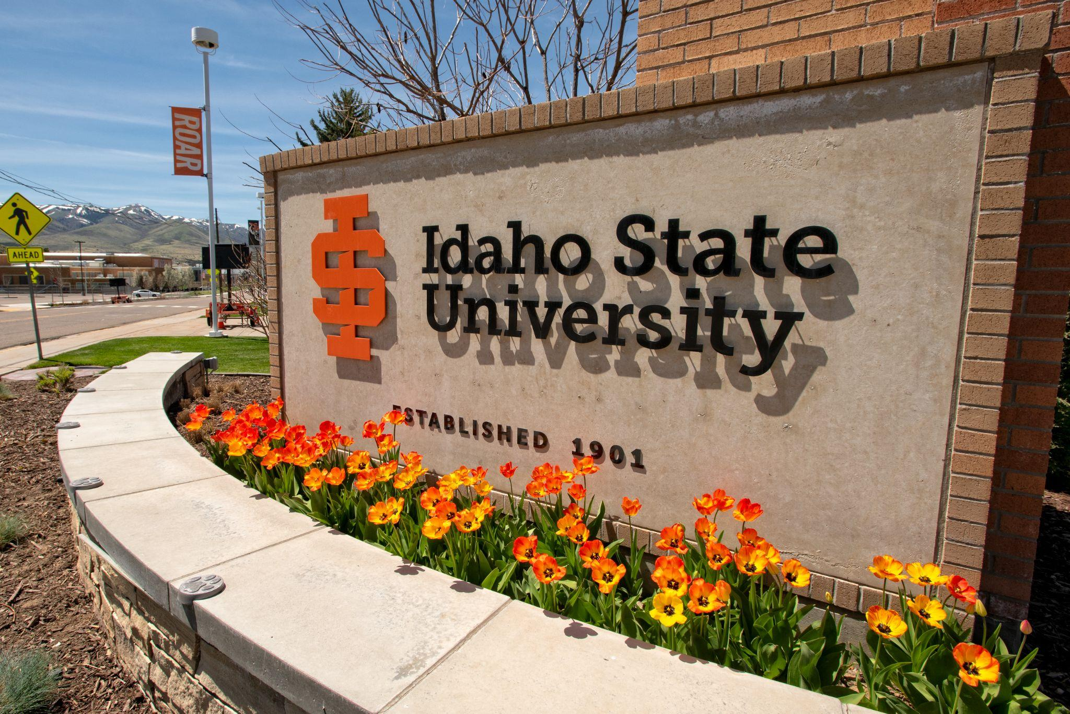  Faculty Senate | The Senate represents the University Faculty in the initiation, consideration, recommendation, and implementation of policy within the purpose and powers of the University Faculty. Various councils report directly to the Faculty Senate and support them through drafting, reviewing and revising policies, addressing issues, overseeing faculty welfare, maintaining academic standards, and other important responsibilities.
Faculty Senate meets in the Shirley Sargent Boardroom, 3rd floor of the PondSUB on alternating Mondays from 4:00 pm - 6:00pm. The Executive Committee meets in The Center for Learning and Instructional Excellence, Rendezvous room 129 on the opposite Mondays.

  FPPC | The purpose of the FPPC is to recommend university policy and procedures to the ISU Faculty Senate in the areas of employment and retention, salary and other compensations, evaluation and its processes, and appeals and grievances. This includes policies related to academic freedom and due process; appointment, reappointment, non-reappointment, termination; tenure and promotion; sabbatical leave; emeritus/emerita status; consulting, faculty professional recognition and development; and legislative policies such as those of the State Board of Education (SBOE) or other proposals affecting faculty welfare.
  RC | The Research Council consists of representative membership across the ISU research community. The Research Council provides a forum for internal discussion, gathers and disseminates information to the faculty, and provides a faculty voice on matters pertaining to research, scholarship, and creative activity. Advocates for institutional support of faculty research. It also initiates and advises on the formulation, review, and application of policies touching on research matters. RC acts in an official advisory role to the Office of Research and provides peer review of internal grant awards funded by the Office. RC selects up to 5 faculty to be Outstanding Researchers and from those recommends the award for Distinguished Researcher.
  GERC | GERC considers all policies related to the University's General Education program and issues recommendations regarding these policies to the UCC. The GERC is responsible for reviewing all proposed changes to the General Education curriculum, approving the appointment of ISU representatives to external bodies with jurisdiction over that curriculum, and establishing and overseeing the process by which the Objectives and courses that compose ISU's General Education program are assessed. The GERC may also issue recommendations regarding other General Education issues brought to its attention.
  UCC | The UCC exercises the faculty's primary responsibility for the fundamental area of undergraduate curricula. Their approval is required for all curricular and program changes that are to appear in the Undergraduate Catalog. The UCC's functions include the identification of potential confusion with existing programs, courses, and degrees due to the proposed title of the new program, course, or degree, as well as identification of potential dilution of existing programs, courses, or degrees. They also provide prevention of duplication with existing programs, courses, or degrees and detection of possible conflict with accrediting standards applying to existing programs, courses, and degrees. The UCC provides continued clarification of the Undergraduate Catalog.
  AIC | The purpose of the Academic Integrity Council is to supervise academic integrity issues at Idaho State University. The AIC oversees ISU’s policies regarding academic integrity, especially as stated in ISUPP 4000, and provides resources for ISU students and faculty in addressing questions and problems regarding academic integrity. In consultation with the Registrar’s Office, the AIC monitors data on instances of academic dishonesty on campus, and in consultation with Educational Technology Services (ETS), it sets the terms with software companies that detect plagiarism and cheating on ISU learning management systems. The AIC also deliberates on individual cases of academic misconduct that meet the requirements of ISUPP 4000.
  ASC | The charge of the Academic Standards Council is to recommend university policy and procedures pertaining to undergraduate academic standards for admission, progression, and the granting of degrees and certificates. Specific areas of concern include but are not restricted to: 1) advising, 2) academic standards, 3) scholastic appeals, 4) admission and progression requirements, 5) honors programs and societies, 6) advanced standing and placement, 7) evaluation of transfer policies, 8) standards for award of ISU credit, and 9) review of academic calendars and scheduling.

Policies
Idaho State University Policy and Procedures (ISUPPS) are formal, documented rules and guidelines that govern the operations and activities of ISU.

If you have questions relating to University Policies, contact:
Mel Anderson, Director of Policy
policies@isu.edu
(208) 282-5585
For questions relating to Academic Affairs Policies, contact:
Laura Ahola-Young
lauraaholayoung@isu.edu
208-282-5713

Our Institutional Policies are categorized in sections that include:
- Governance/Legal
- Finance
- Human Resources
- Academic Affairs
- Student Affairs
- University Advancement
- Research
- Athletics
- Public Safety
- Information Technology Services
- Facilities and Operations
The Idaho State University Libraries serve the university community by providing collections and services in support of the university's teaching and research missions. As the largest state-supported library in eastern Idaho, the Libraries also play a role in the development of university cooperative programs and in the provision of library services to the citizens of Idaho.

The first point of contact for questions about the library and its resources should be the department liaison

What to know: Each department chair names someone within their department to serve as a designated liaison to the library. This individual coordinates with the department and the library on available resources, updates, and other information. The University Library Committee (ULC) is responsible for clarifying the roles and responsibilities of the liaisons at the department level.

It is recommended that faculty pre-plan the resources that students need to access each semester and coordinate with the library through their liaison so that the library is aware of the requested resources and they are then able to work to get access to those resources.

- Be aware that some resources may be harder or impossible to obtain - early coordination with the library can prevent later roadblocks if a resource cannot be obtained

Library funds are centralized then allocated across the departments. While some departments opt to put their funds toward journals, others choose to put them toward books or other media. Be mindful of where the funds are designated. Some departments also give the library permission to use a portion of the funds obtained through course fees to fund library resources for their department - this may be an option to consider when planning for a resource.

Access the Library’s presentation from New Faculty Orientation here.

  Outdoor Adventure Center |   Idaho Museum of Natural History | 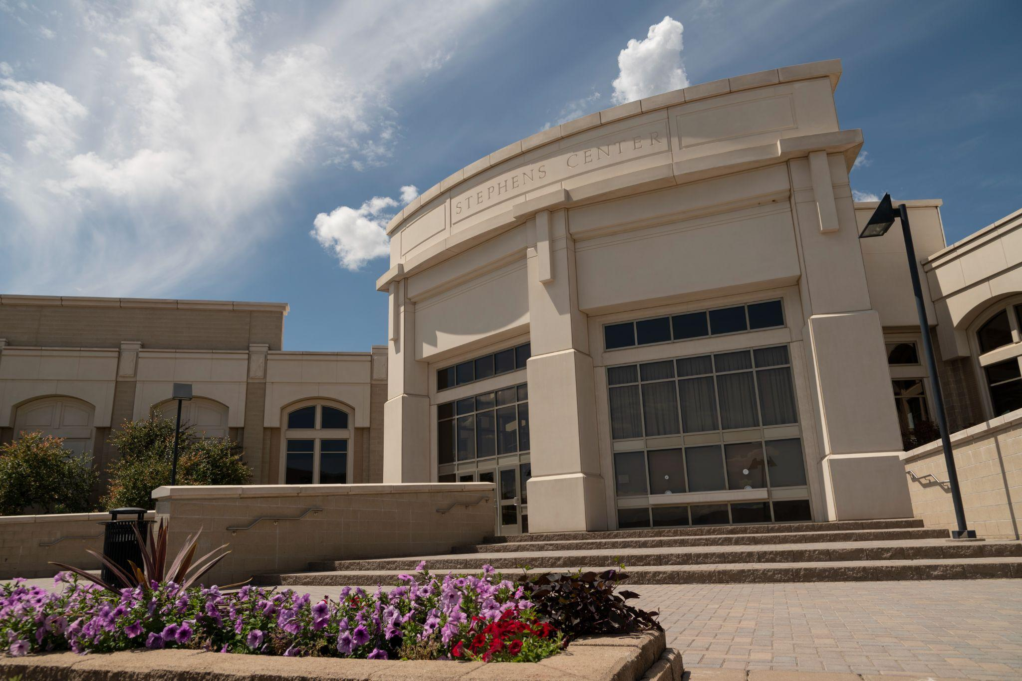  Stephens Performing Arts Center
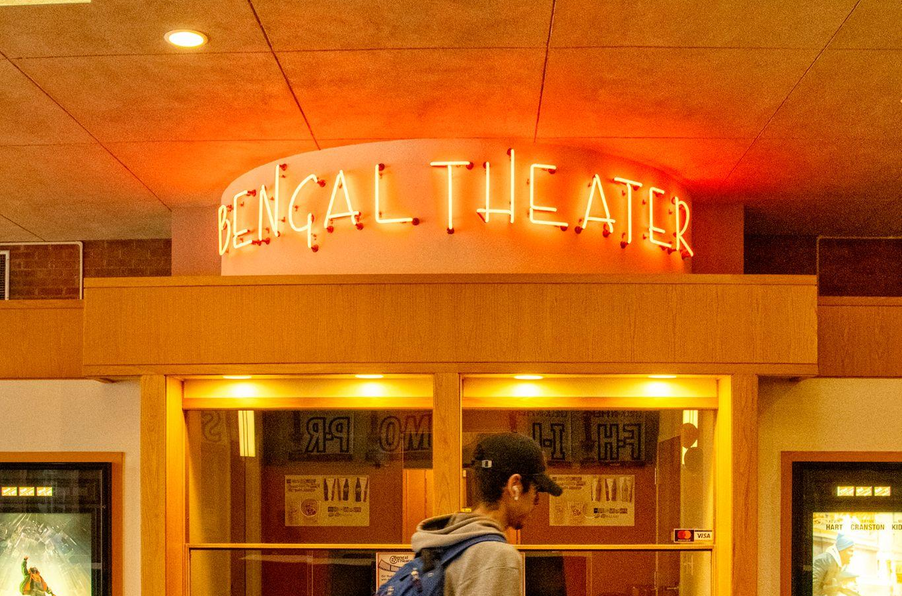  Bengal Theater |   Reed Gym | 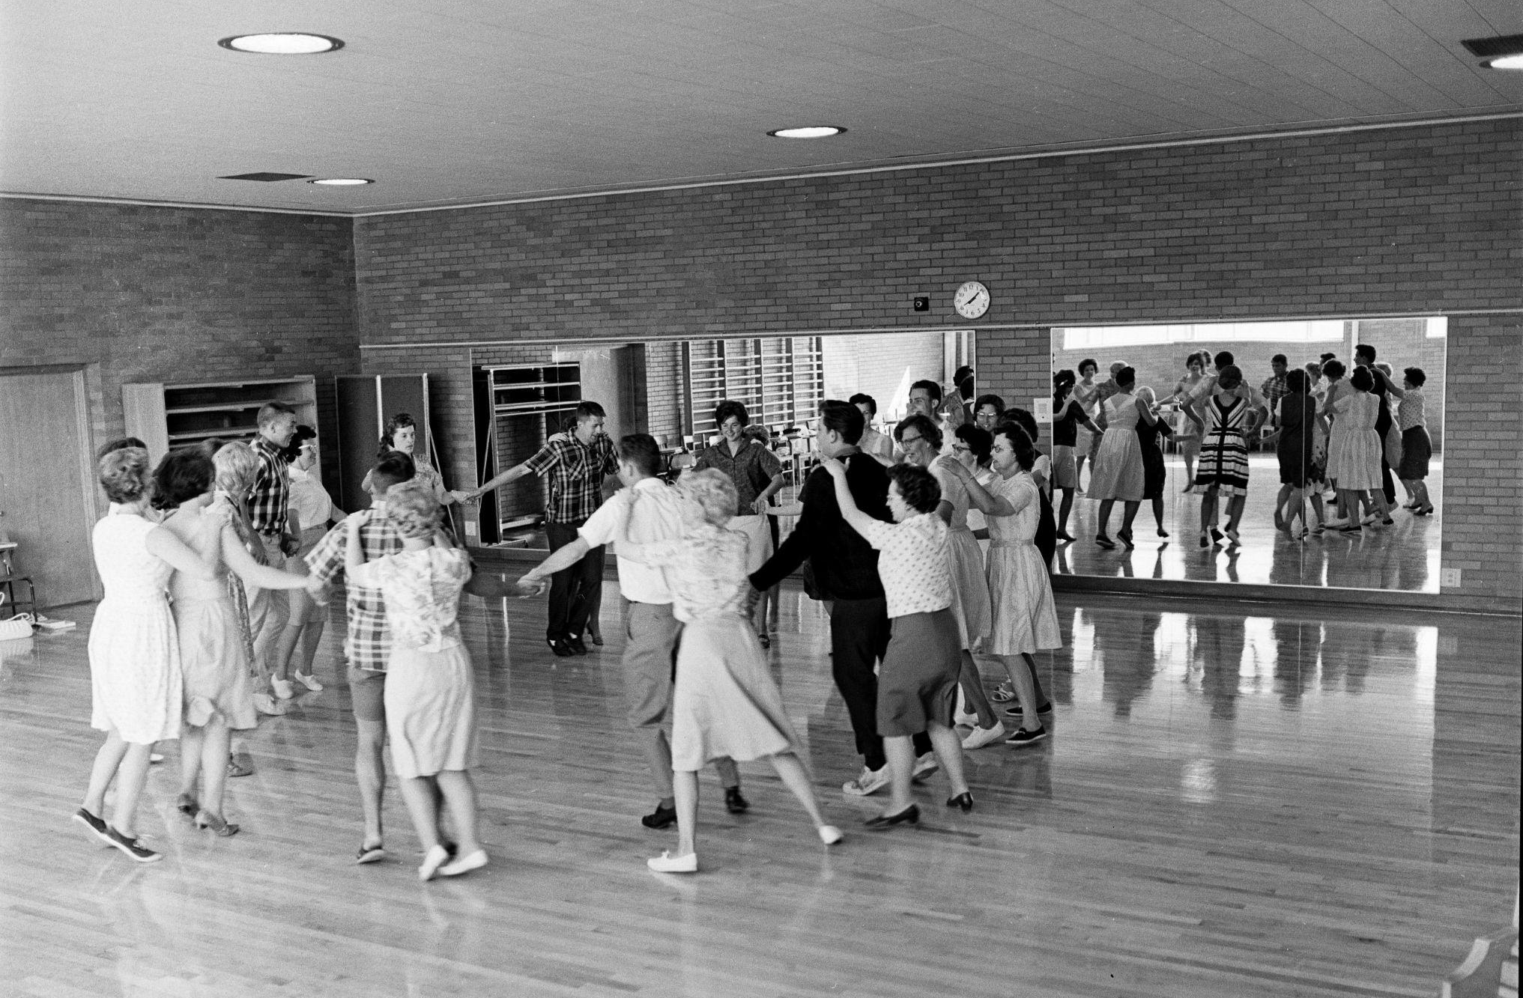  Fitness Classes
  ISU Athletic Events |   ISU Games Center |   ISU Craft Shop

Purchasing

Jaggaer
Jaggaer is an online procurement system that provides an end-to-end online experience for the entire procurement process. When items are purchased for your department, you should check whether the items are available through the affiliated businesses linked in Jaggaer first.

For questions or concerns,
contact Bonnie Liston in the Purchasing Office
purchasing@isu.edu
208-282-3923

How to Access:

- Log into MyISU
- In the upper left-hand corner - click on hamburger button:
- Then click on Discover and enter “Jaggaer”
- Once the channel comes up, bookmark it so it appears on your homepage.

**Follow this same process to find Jaggaer the and the “Finance Tools” channel.

Jaggaer E-Procurement
Jaggaer Training and Resources

PCARD
The Purchasing Card (PCard) ISUPP 2570 program is intended to provide a simple, efficient, cost-effective means of purchasing small dollar and/or low-risk items. It is recommended that there be a departmental PCard that can be checked out to people for dinners, etc.

Jenny Stilling, Pcard Administrator
Purchasing Services
Office: Administration Building, Room 229 Finance and Administration
(208) 282-3112
stiljenn@isu.edu

What to know: The section below will cover how to get a purchasing card, how to access the section in MyISU, and the reconciliation process.

How to Get a Card:

- Fill out a Cardholder Application
- Send completed application to Jenny Stilling.
- When Purchasing receives the PCard application, an invitation will be sent with instructions on how to take mandatory Moodle training.
- After training has been completed, call 282-3112 to set up a time to obtain your new ISU PCard.

Purchasing will process your application as quickly as possible. PCards are normally received within 10 business days.

How to Access:

- Log into MyISU
- In the upper left-hand corner - click on hamburger button:
- Then click on Discover and enter “Purchasing Card”
- Once the channel comes up, bookmark it so it appears on your homepage.

**Follow this same process to find the and the “Finance Tools” channel.

Reconciliation:

Purchases are reconciled in the Bank of America P-Card Reconciliation (Works)
Reconciling Quick Guide

Human Resources
All HR Forms can be found here: HR Forms
Please see the list below to find out who to contact in HR for specific questions

General HR Services
hr@isu.edu
208-282-2517

- New hire paperwork (W-4, I-9, etc)
- Employee/Spouse/Dependent Tuition Reduction forms
- HR process/paperwork questions
- General questions
- Remote Work Application & Safety Checklist/ Remote Work Agreement forms
- Student, Temp, and Adjunct background checks
- HR Information Systems (HRIS)

Abhilaasya Chennuri, HRIS Analyst
abhilaasyachennur@isu.edu
208-282-4897

- Employee reporting from Banner
- Banner Access Setup
- Employee data and Time approver proxy setup
- EPAF Security
- Personnel Action Processing

Katie Baca, Program Information Coordinator
208-282-4420
or
Tracy Mull, Personnel Technician for Data Processing
epaf@isu.edu
208-282-3724

- EPAFs
- PRs
- Personnel info in Banner

HR Policy Questions
Angie Dangerfield, Associate VP for HR
angiedangerfield@isu.edu
208-282-4291

- General questions about the application of ISU HR, DHR, and/or State Board of Education policies

FMLA
The Family and Medical Leave Act (FMLA) is a federal law in the United States that allows eligible employees to take up to 12 weeks of unpaid, job-protected leave within a 12-month period for certain family and medical reasons. It also ensures that employees' group health insurance coverage continues under the same terms as if they were working. ISU’s FMLA Policy outlines some information that is helpful to know regarding this leave but it is also advised that employees consult with HR regarding specific questions they may have.

For questions about a potential situation being FMLA eligible, contact:
Human Resources
fmla@isu.edu
For performance or attendance concerns while an employee is using FMLA, contact:
Dani Gribas
208-282-3081
gribdani@isu.edu

What to know:
- Eligibility Requirements: Employees are eligible for FMLA leave if they have worked for the employer for at least 12 months, and have 1,250 hours of service in the past year.
- Leave Entitlement: Eligible employees can take up to 12 weeks of unpaid, job-protected leave in a 12-month period for qualifying reasons.
- FMLA Communication: Supervisors may inquire about scheduling, workload, and FMLA leave start and end dates. Supervisors should never inquire about any details or information about the employee’s medical condition.
- Supervisory Responsibilities at a glance: Supervisors must recognize potential FMLA situations, maintain confidentiality, avoid retaliation, and direct employees to HR for guidance on leave processes.

Payroll
The primary function of Payroll is to ensure timely and accurate payment to Idaho State University employees. Payroll at Idaho State University is on a bi-weekly pay schedule with payments made to employees every other Friday.

Please see below to find out who to contact in HR for payroll questions:

Janice Romero, Benefits Coordinator/Interim Payroll Manager
208-282-3106
Renea Midthun, Payroll Technician
208-282-1353
payroll@isu.edu

- Time review/approvals
- Timesheet or paycheck questions/issues
- Payroll processing
- Payroll taxes and other withholdings
- Post-tax payroll deductions (Meal Plan, Campus Rec, Parking etc.)
- Time approver (T-ORG) questions
- Labor redistributions (Payroll JV)

What to know: The university requires the use of direct deposit.
- Each pay period the employee’s paycheck will be deposited directly into their checking or savings account.
- There are two ways employees can add/update their direct deposit information. Employees can either add/update their information directly in MyISU using the Payroll Direct Deposit Guide or they can update it in-person with HR.
- Any changes to direct deposit information must be made by the timecard due date on the pay date/payroll calendar to be effective for the desired pay date.
- Contract and Payroll Dates for 2025

The Graduate School
The Graduate School oversees graduate education across a wide range of disciplines. It supports advanced academic and professional training, offering master's, doctoral, and specialist degree programs, as well as graduate certificates. The school focuses on fostering research, scholarship, and creative activity while preparing students for leadership roles in their respective fields. It provides services such as admissions guidance, academic support, funding opportunities, and professional development resources to enhance the graduate student experience.

For questions or concerns, contact: The Graduate School Team gradschool@isu.edu
If a student requires additional support, they can contact the Graduate Dean
What to know: The Graduate School is located on the 4th floor of the Museum building and is responsible for a wide range of processes as it relates to graduate students and applicants, including:
- Applications and Admissions (via CollegeNet)
- Transfer of credits
- Graduation
- DegreeWorks plans and exceptions
- Committees
- Appeals and Dismissal
- Academic Dishonesty
- Student Training and Professional Development
- Student Funding (summer, travel, etc)
- Oral Examination Scheduling
Organization and Meetings: All colleges have a designated program manager - contact the Graduate School for further information on who your program manager is.
If someone wants to make changes to a course, program, or degree within the graduate school (hiatus, start, closing, etc) the Graduate School should be the first point of contact to begin the review process.
Each semester, graduate program directors meet to discuss admissions and recruitment, student support and success, program development, policies and procedures, and assessments and outcomes.
Each year, Administrative Assistants meet to discuss processes, common issues, and provide a collaborative experience aimed at supporting students, staff, and faculty.
Graduate Teaching Assistantships (GTAs) are graduate students who are employed to assist with teaching-related duties as part of their academic training. They are typically assigned to support faculty in delivering undergraduate courses, which may involve tasks such as:
- Leading discussion or lab sections
- Grading assignments, quizzes, or exams
- Preparing course materials
- Providing student support through office hours or tutoring
These positions are designed to support the graduate student’s professional development while contributing to the university’s educational mission. Specific responsibilities and benefits may vary depending on the department or program.

Public Safety
The Department of Public Safety operates on the Pocatello, Idaho Falls, and Meridian campuses and is responsible for providing safety and security services for the ISU community. It includes patrol and dispatch units, emergency management, Clery compliance, and parking and transportation services.

For 24/7 assistance, questions, or concerns, contact:
The Dispatch Center
208-282-2515
pubsafe@isu.edu

What to know: The department’s patrol unit consists of armed security officers who work diligently with the ISU community and surrounding partner agencies to ensure a prompt and coordinated response. Public Safety officers patrol the campus by foot, bicycle, motorcycle, and vehicle. The department’s core duty is providing a safe and secure environment and providing crime prevention through the deterrence of crime by:
● Performing regular and random patrols of the facilities to watch for potential safety hazards and criminal incidents
● Checking to ensure buildings are secured
● Providing safety escort services to students, faculty, and staff across campus to ensure that they can traverse campus without fear of personal harm
● Conducting security surveys for campus departments by request and may suggest improving the physical security of buildings, offices, and parking lots by installing security cameras and door access card readers
● Assisting campus units with planning effective campus events
● Assisting any individual or group in planning, presenting, and coordinating programs of interest or concern
● Documenting and referring issues to the University staff responsible for the area or facility.

About ISU
Founded in 1901, Idaho State University and its students are leading the way in the areas of energy, health professions, nuclear research, teaching, humanities, engineering, performing and visual arts, technology, biological sciences, pharmacy, and business.

Idaho State offers high-quality education in more than 250 programs and is the state's designated lead institution in health professions. Students can choose from degrees in more than 50 health-related areas, including nursing, pharmacy, physical therapy, speech pathology, and physician assistant studies. In addition to significant offerings in health sciences, the University offers a wide array of graduate programs through colleges in business, education, technology, arts and letters, and science and engineering.

Faculty and staff at Idaho State are dedicated to student success. The University is more than an institution — it is a community where the guiding principles are trust, compassion, stability, and hope.

At Idaho State, students enjoy a personal connection with faculty, with a low student-to-teacher ratio of 13:1. As a state leader in the health sciences, ISU offers hands-on experience for students and widespread health services to the community at more than a dozen clinics across the state. Education at Idaho State is filled with real-world experience; the $2.3 million Career Path Internship program helps aid hundreds of students' career goals by pairing students with paid on- and off-campus internships and research experiences. In their spare time, students can choose from more than 150 student organizations, enjoy whitewater rafting, backcountry experiences and more through the Outdoor Adventure Center, or drive to Craters of the Moon National Monument or Yellowstone National Park.

The L.E. and Thelma E. Stephens Performing Arts Center on the ISU campus is nationally ranked as one of the most impressive performance venues on a university campus. It is home to the Idaho State Civic Symphony and is also host to numerous plays, concerts, recitals, and art performances. Idaho State combines exceptional academics amidst the grand natural beauty of the West. Only a few minutes from campus, you can find world-class skiing and snowboarding, hiking, mountain biking, and rock climbing. As an NCAA Division 1 school, ISU competes in the Big Sky Conference offering robust athletic programs to students such as basketball, cross-country, tennis, track and field, volleyball, softball, football, golf, and soccer.

Traditions
From an annual day of service to a weekly showcase of school spirit, Idaho State proudly celebrates a number of campus traditions. We encourage all faculty and staff to join our students and alumni in taking part in all of our longstanding University traditions.

One tradition that we widely encourage is Bengal Wednesday. When you walk across campus––or wherever you are in the world––stand united with your fellow Bengals and wear orange and black on Wednesdays with pride.

To learn more about Idaho State’s traditions, go to isu.edu/traditions

Quick Facts
- From traumatic brain injuries to post wildlife recovery, Idaho State is home to more than 200 research labs.
- The L.E. and Thelma E. Stephens Performing Arts Center is ranked as the fourth best performance venue on a college campus.
- Holt Arena is the oldest covered stadium in the nation and the first on a college campus.
- As the State of Idaho’s health care university, ISU offers 75% of the state’s health profession degree programs.
- The University has more than 100,000 alumni.
- Students come to Idaho State from all 44 counties in Idaho, 48 states in the U.S., and 59 countries.
- Earnings from ISU alumni living and working in Idaho contribute more than $900 million to the State’s economy.
- Pocatello was named a top community for outdoor enthusiasts by Livability.
- Idaho State was named a top college for skiers in the Mountain West by Powder Magazine.

Mandatory Reporting
What to know: Idaho State University is committed to providing a workplace and educational environment, as well as other benefits, programs, and activities, that are free from discrimination, harassment, and retaliation. To ensure compliance with federal and state civil rights laws and regulations and to affirm its commitment to promoting the goals of fairness and equity in all aspects of the education program or activity, ISU has developed internal policies and procedures that provide a prompt, fair and impartial process for those involved in an allegation of discrimination or harassment on the basis of protected class status, and for allegations of retaliation. ISU values and upholds the equal dignity of all members of its community and strives to balance the rights of the parties in the grievance process during what is often a difficult time for all those involved.

For questions about the Mandatory Reporting, contact:
Ian Parker, Title IX/Title VI Coordinator
ianparker@isu.edu
208-282-1439
titleix@isu.edu

How to report a concern/Title IX website
What does it mean to be a mandated reporter?
Mandated reporters are required by ISU policy to report to the Title IX Coordinator any incident of sexual misconduct or gender-based harassment, including all information they know about the incident. Examples of gender-based harassment include: unwanted touching on any part of the body, comments about someone’s body, dress or physical appearance that make that person uncomfortable, stalking behaviors, domestic or dating violence situations, repeated requests for dates or social interactions.
*As a Mandated Reporter, you are not responsible for investigating or asking questions—just reporting what you are told.
How do I know if someone else is or if I am a Mandated Reporter?
All ISU employees are Mandatory Reporters, including:
- All Vice Presidents, Assistant Vice Presidents, Associate Vice Presidents, Provosts, Deans, Department Chairs, Directors, and Coaches;
- All Title IX Coordinators;
- All Human Resources staff;
- All staff (including, for purposes of clarity, Resident Assistants and Advisors);
- All employees serving in a supervisory or management role (including, for purposes of clarity, all employees who supervise activities or programs that involve direct contact with students, such as advisors to recognized student organizations);
- All members of the faculty; and
- All ISU Public Safety personnel.
The only ISU employees who are not mandatory reporters are Counselors and Health Care providers engaged with patients/clients in a health care setting.
When should I report an incident to the Title IX Coordinator?
You should report the incident as soon as possible after you become aware of the incident whether by your own observation or by a report from another individual. Mandated Reporters are expected to inform the Title IX Coordinator of any reported Sexual Misconduct within 24 hours of receiving a report.
What information should I report?
All known facts, including the names of all involved, status of all involved (student, staff member, faculty member, not university-affiliated, etc.), the date of the incident, the alleged conduct and the location of the incident.
When the Title IX Coordinator receives the report, they will reach out to the impacted person to provide support and discuss options for resolution.
You can file a report through email, by phone, or online.
What should I do first when an individual starts telling me about an incident of sexual harassment, gender-based harassment, intimate partner violence, stalking or sexual violence?
*If someone tells you about an incident of sexual misconduct, your response can help the healing process.
Gently interrupt that person as soon as possible to advise him or her of your reporting obligations, and ask if he or she still wants to describe the incident to you. Explain that you cannot keep confidentiality. Explain that the Title IX Coordinator will only share the information with those who need to know in order to take appropriate action to address the problem. Advise the person that you can support them by contacting the Title IX Coordinator, who can fully explain the support services available and the steps that will be taken to address the reported incident.
If the individual still wants to tell me about the incident, what can I say or do to support them?
- Listen to them.
- Acknowledge what they are telling you.
- Don’t judge what they tell you.
- Do not try to investigate on your own.
- Thank them for sharing with you.
- Encourage them to reach out directly to the Title IX Coordinator and report the incident.
- Remind them you will be reporting it as well.
What you should NOT do:
- Do not tell the complainant to ignore the behavior.
- Do not make light of the situation.
- Do not attempt to investigate or resolve the situation on your own.
- Do not wait for someone to complain if you know or suspect sexual misconduct is or has occurred.
- Do not promise confidentiality
If the complainant says that she or he wants me to maintain confidentiality, what should I do?
Prior to hearing the particulars of the complaint, you should advise the complainant that you are unable to maintain confidentiality and would need to report the incident to the Title IX Coordinator. If the complainant continues to state that he or she wants confidentiality, you should direct student complainants to the confidential resources: Counseling Services or the student health center.
How can I support a student/faculty/staff complainant as a responsible employee?
If someone discloses an incident of sexual misconduct to you, including sexual assault, stalking, dating or domestic violence, or sexual harassment, we encourage you to take the following steps:
- LISTEN and start by believing. It isn’t your job to investigate the issue. Suspend any judgment and avoid victim-blaming.
CONFIRM the student’s safety. If they are not safe, work with the Title IX Coordinator to help them create a plan to get to a safe place.
PROVIDE nonjudgmental support. Avoid questions that suggest blame or show doubt.
RESPOND with compassion and sensitivity.
- REVIEW reporting options with the student (both the right to file a report with law enforcement and the right to file a complaint with the Title IX Coordinator).
DIRECT the student to on-campus support resources, such as Counseling Services and the Student Health Center.
CONTACT the Title IX Coordinator to report the incident.
EXPLAIN to the student that the Title IX Coordinator will contact them to discuss their reporting options and resources.

